**School of Computer Science**

**UNIVERSITY OF PETROLEUM AND ENERGY STUDIES**

**DEHRADUN, UTTARAKHAND**



System Monitoring And Configuration Management

**Lab File**

**(2024-2025)**

**for**

**6th Semester**

Submitted To: Submitted By:

Dr. Hitesh Kumar Sharma Shruti .

B. Tech. CSE DevOps

[6h Semester]

Sap id- 500092973

Batch 2

R2142210750

**EXP 2 : Terraform AWS provider IAM user setting**

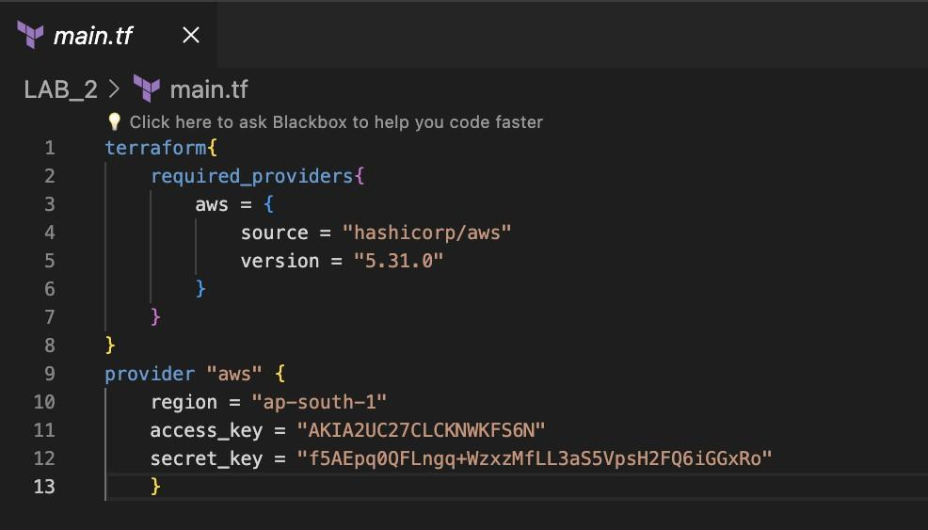

Terraform init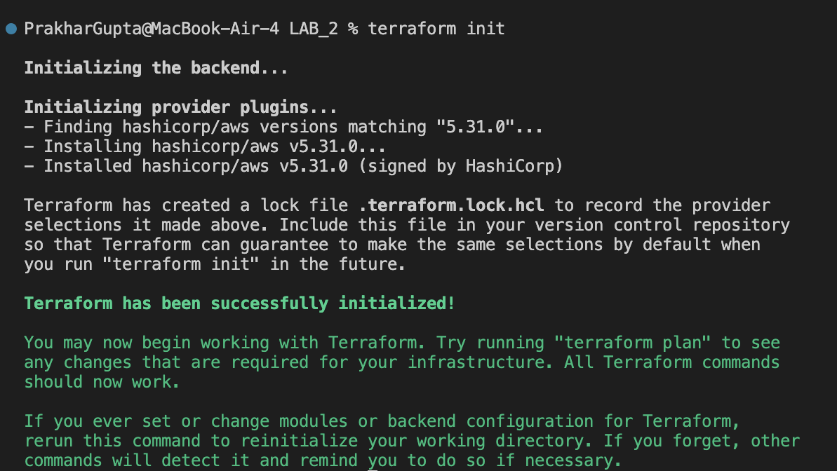

**EXP 3 : Provisioning an EC2 Instance on AWS**

Creating a file named main.tf

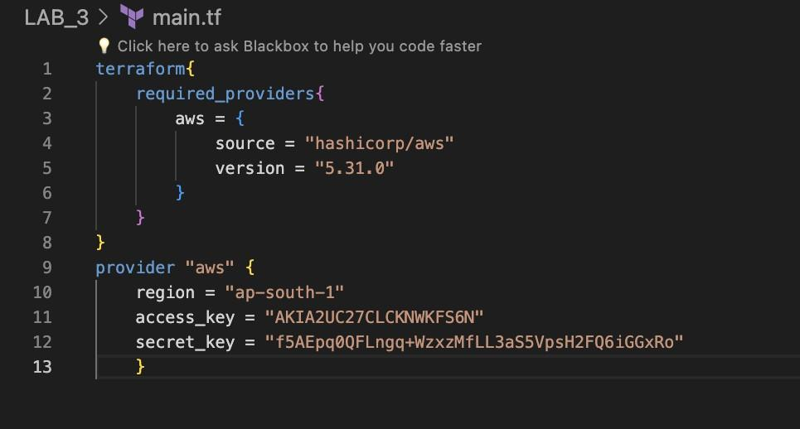

Terraform init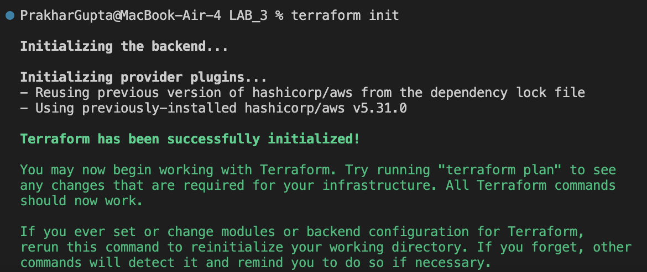

Creating a file named instance.tf

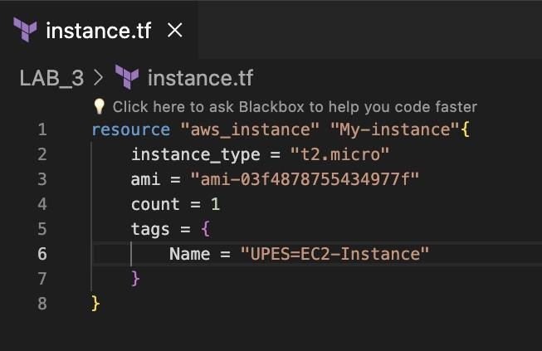

Terraform Plan

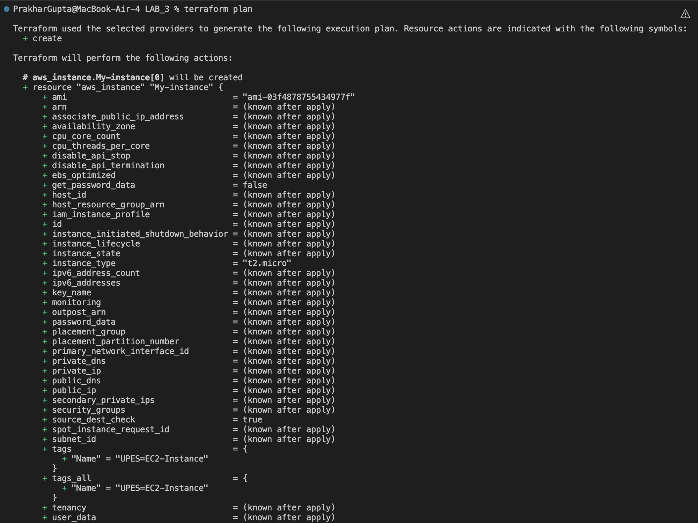

Terraform Apply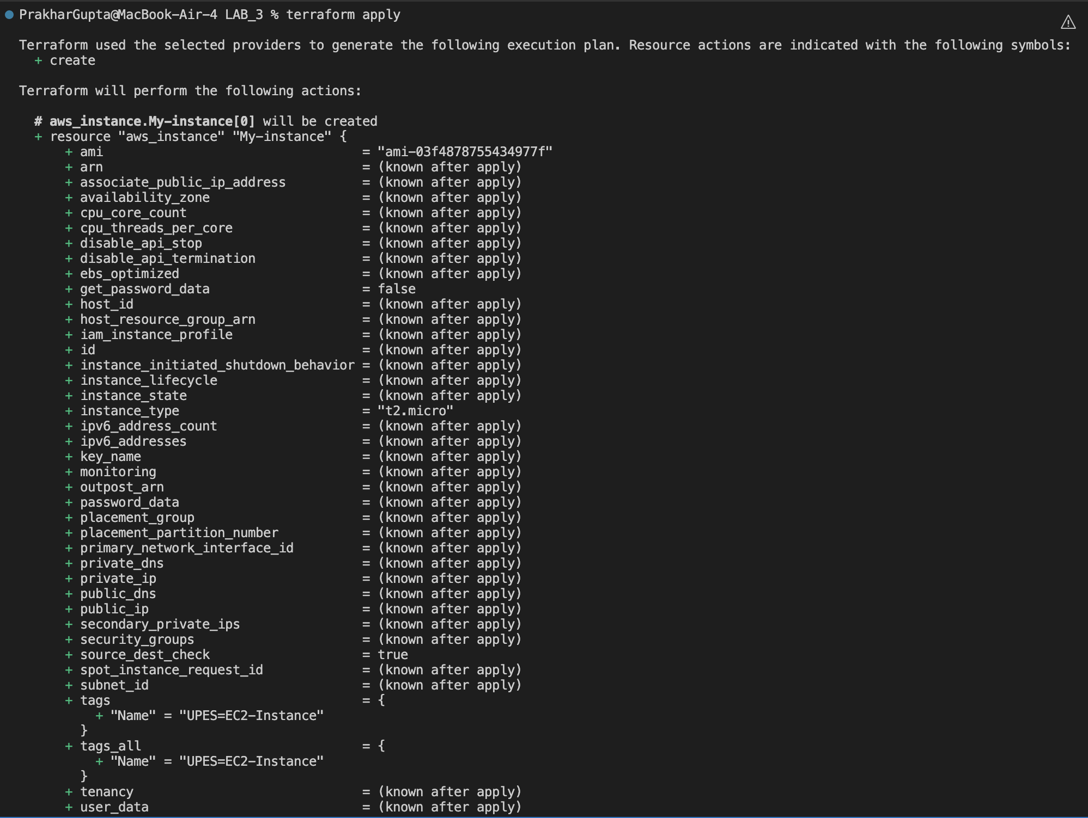

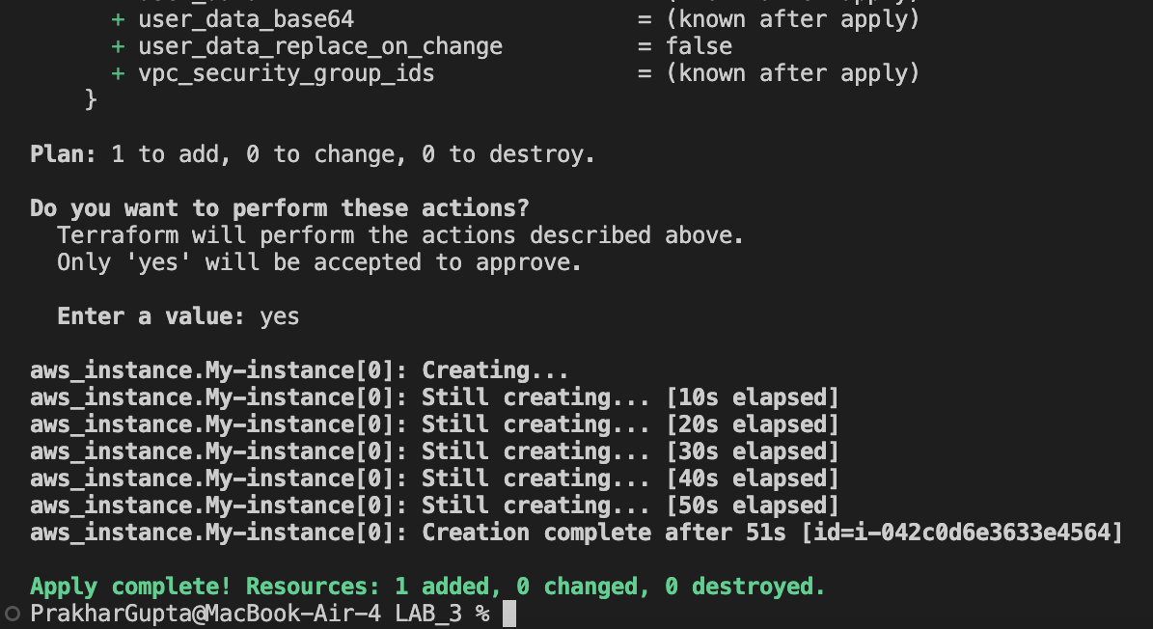

Terraform destroy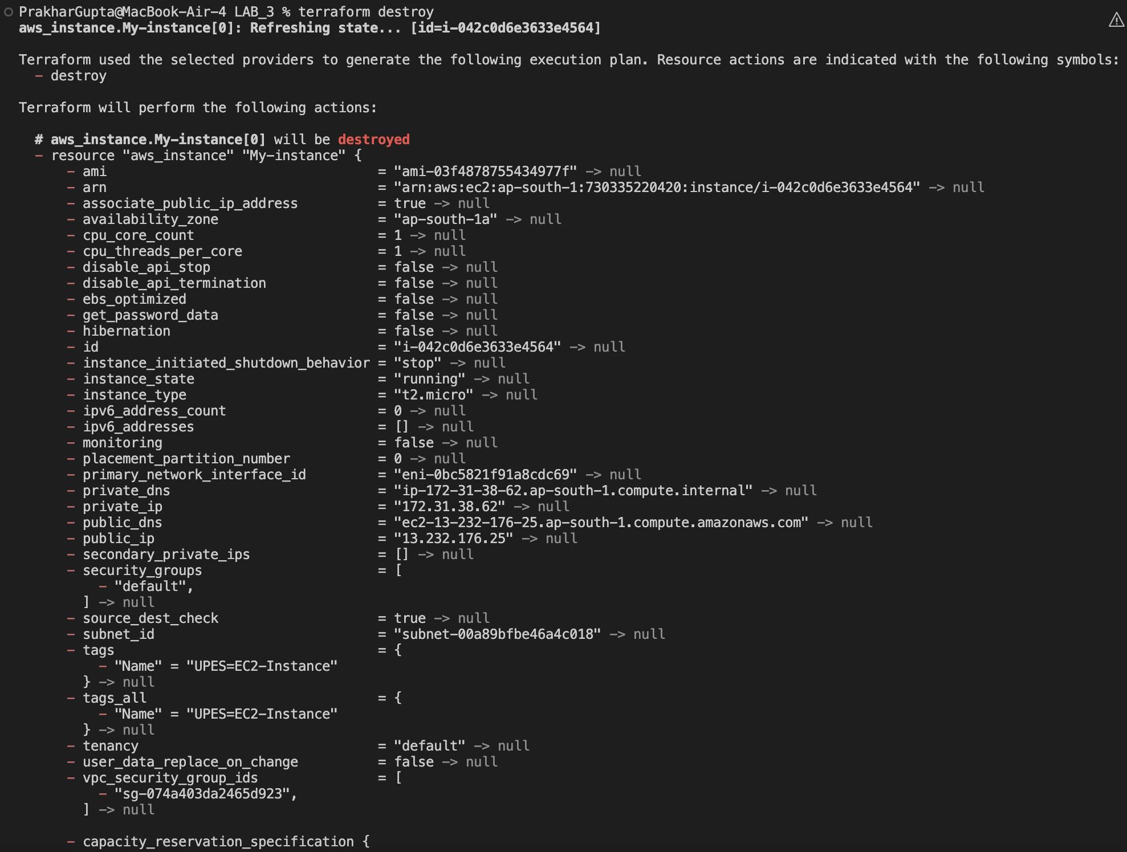

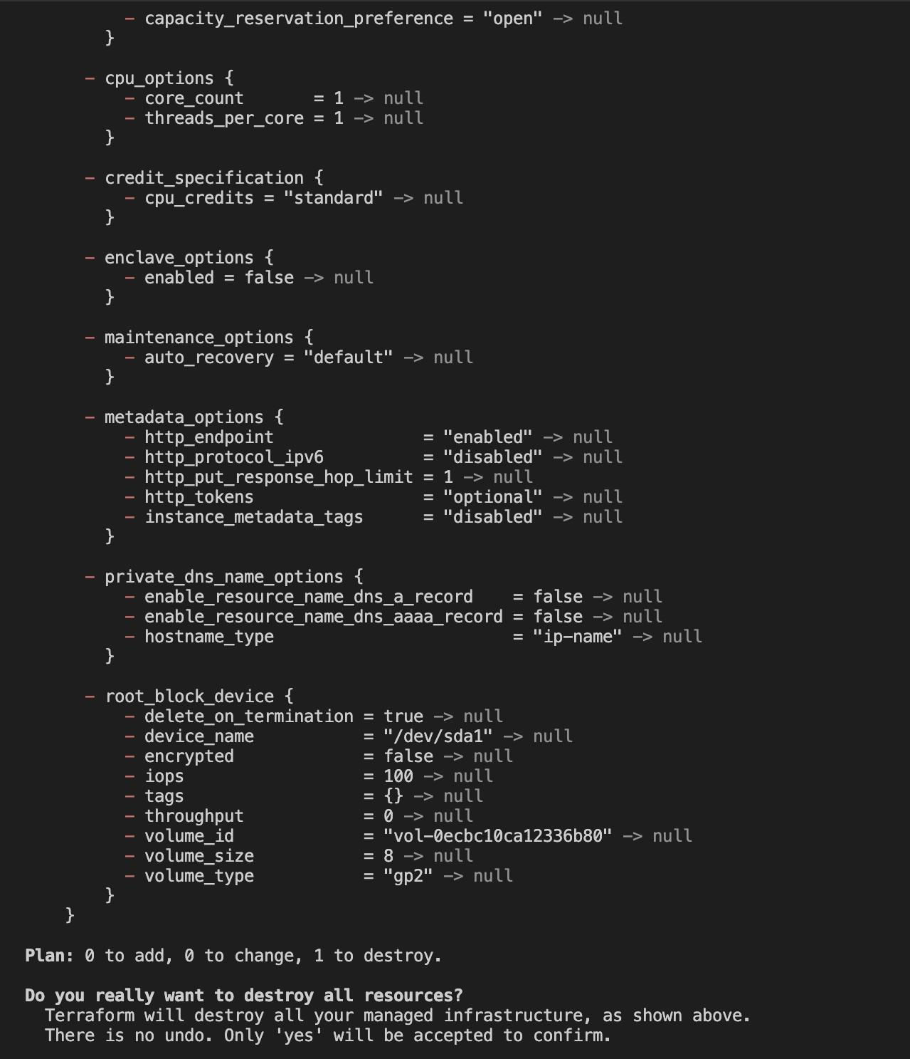

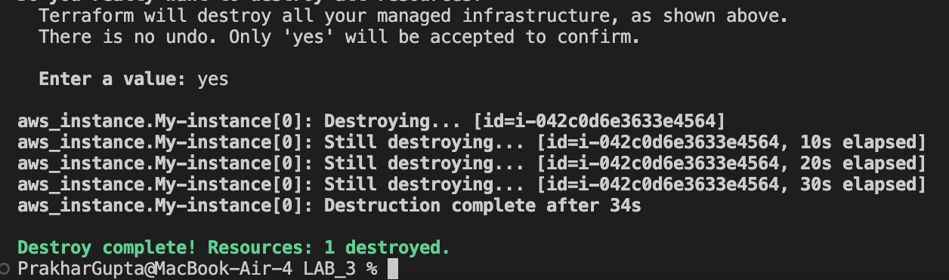

**Lab Exercise 4– Terraform Variables**

Objective: Learn how to define and use variables in Terraform configuration.

Steps: 1. Create a Terraform Directory:

• Create a new directory for your Terraform project.

2. Create a Terraform Configuration File:

• Create a file named main.tf within your project directory. # main.tf

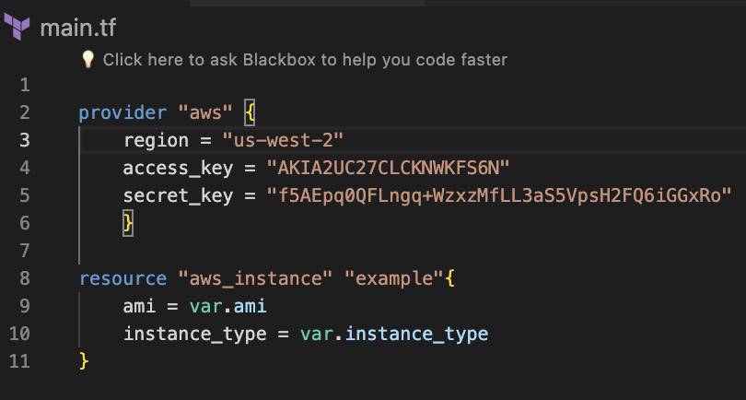

3. Define Variables: • Open a new file named variables.tf. Define variables for region, ami, and instance_type. # variables.tf

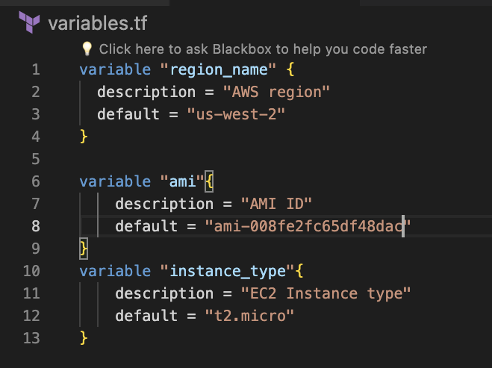

4. Use Variables in main.tf: • Modify main.tf to use the variables. # main.tf

5. Initialize and Apply: • Run the following Terraform commands to initialize and apply the configuration.

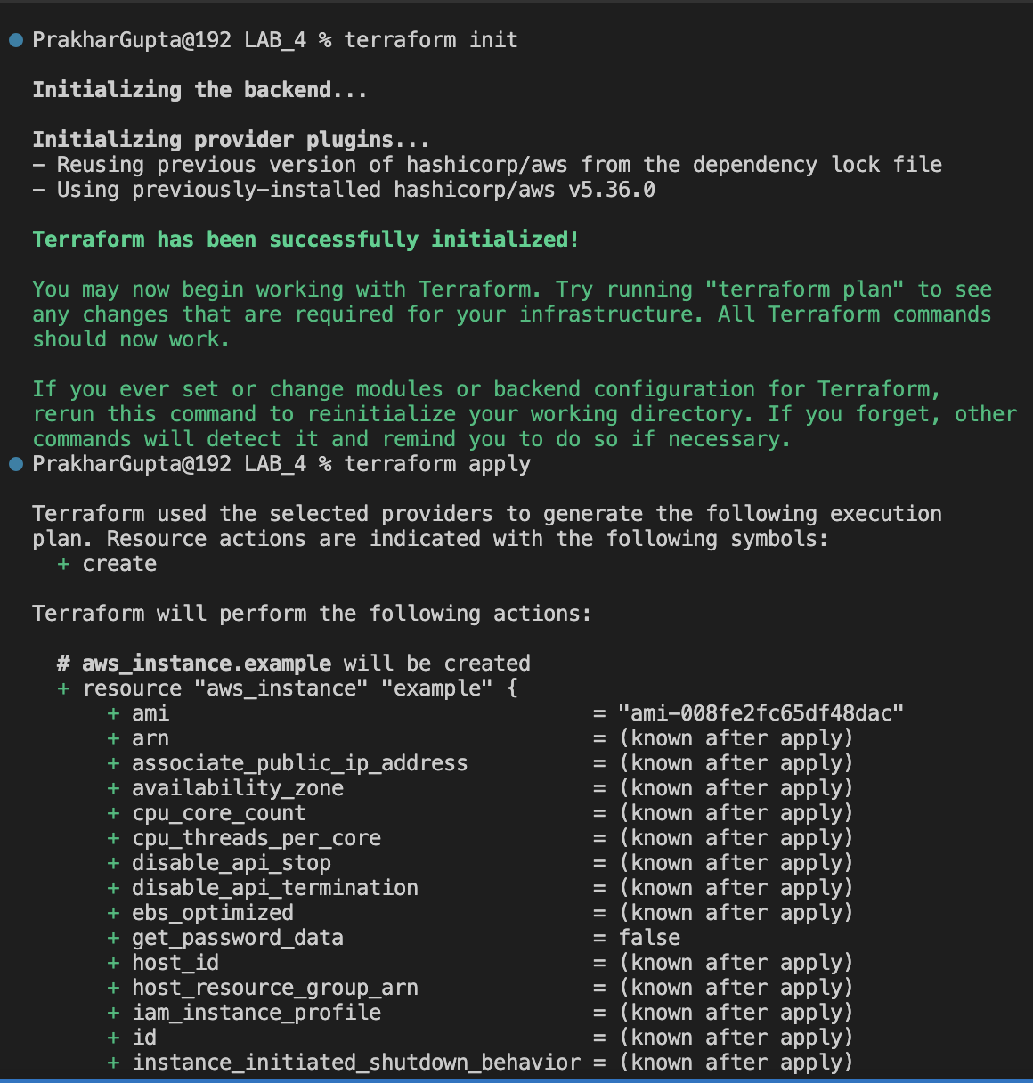

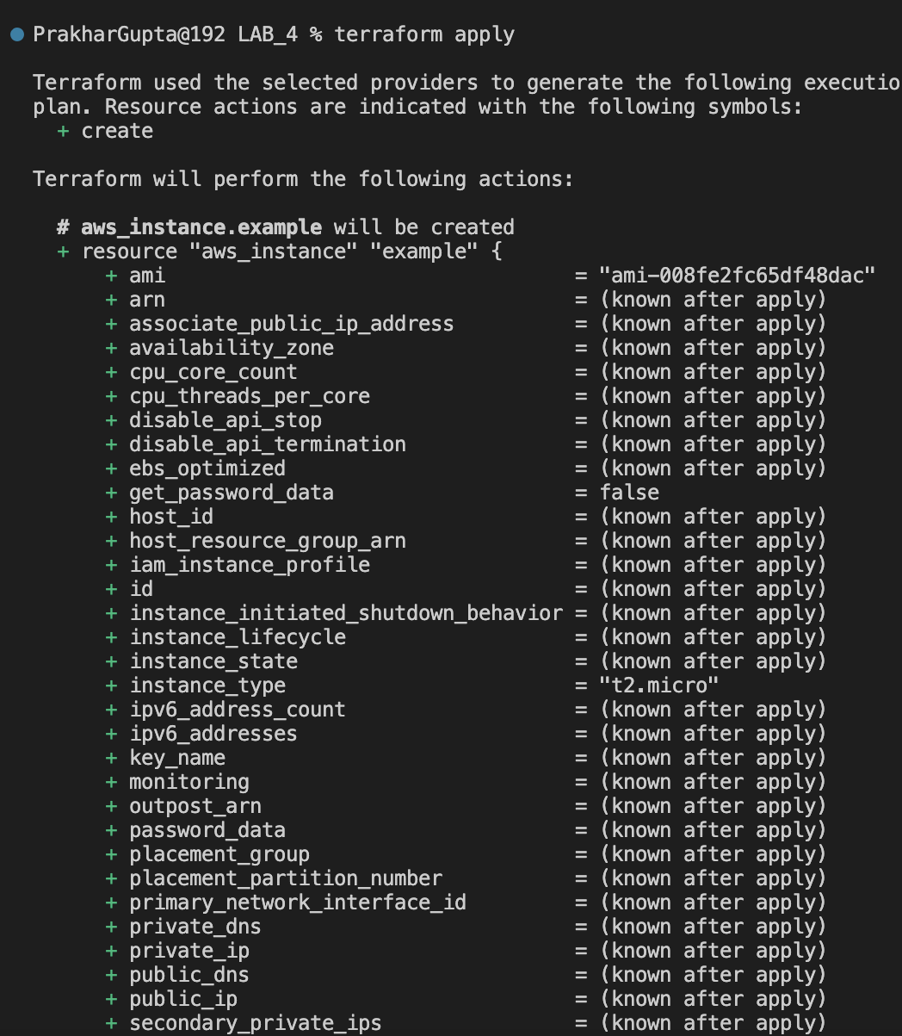

Observe how the region changes based on the variable override.

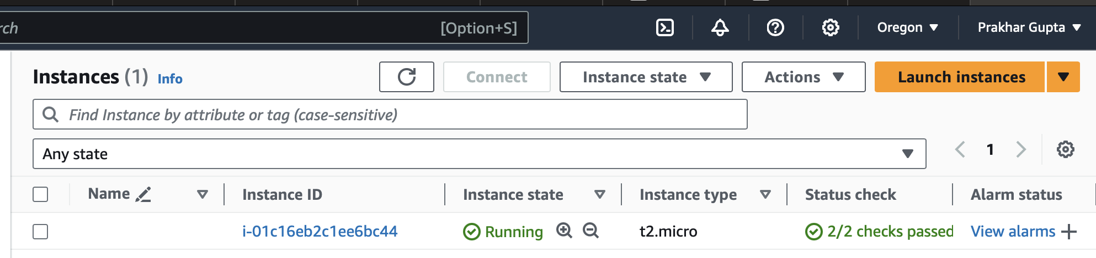

6. Clean Up: After testing, you can clean up resources.

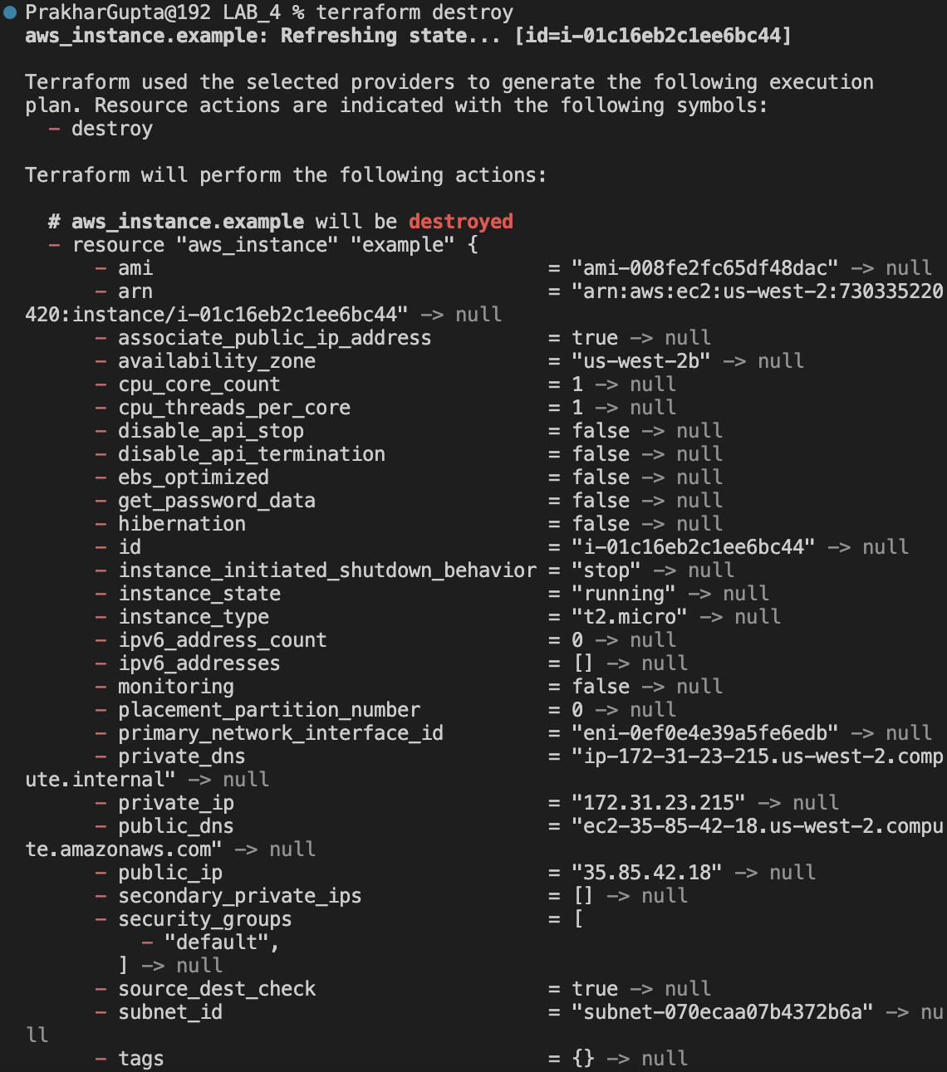

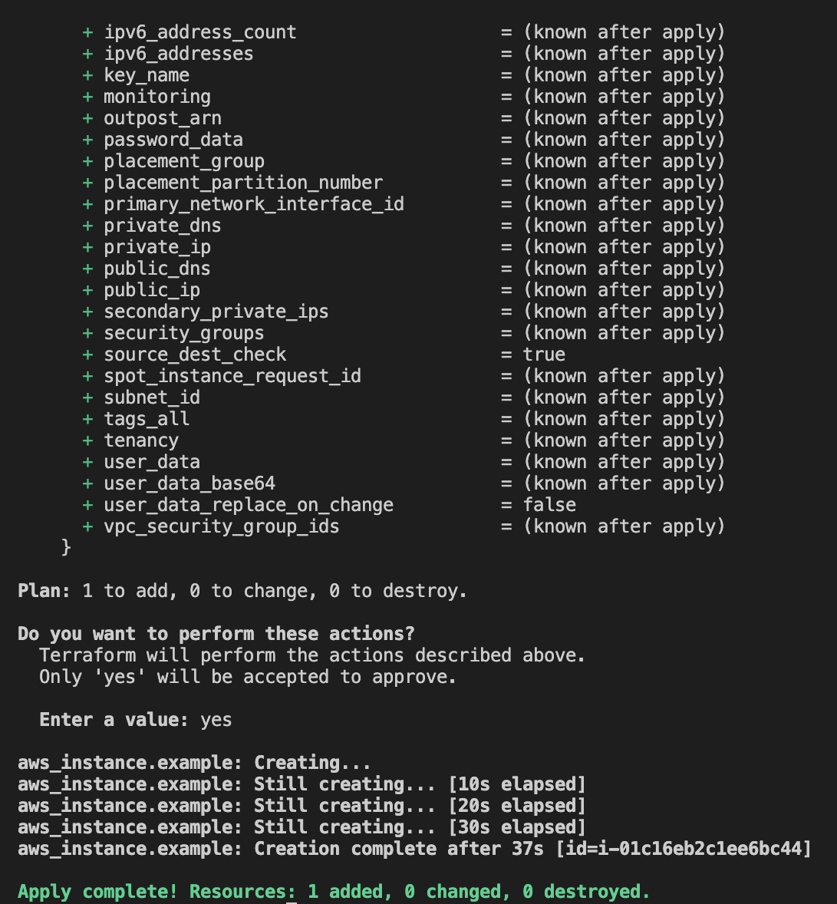

**Lab Exercise 5– Terraform Variables with Command Line Arguments**

. Use Command Line Arguments: • Open a terminal and navigate to your Terraform project directory. • Run the terraform init command:

Run the terraform apply command with command line arguments to set variable values:

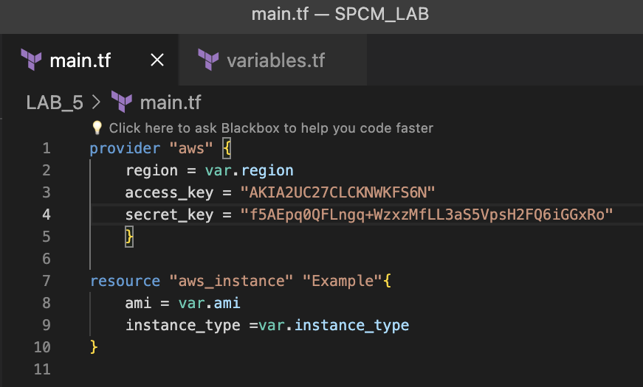

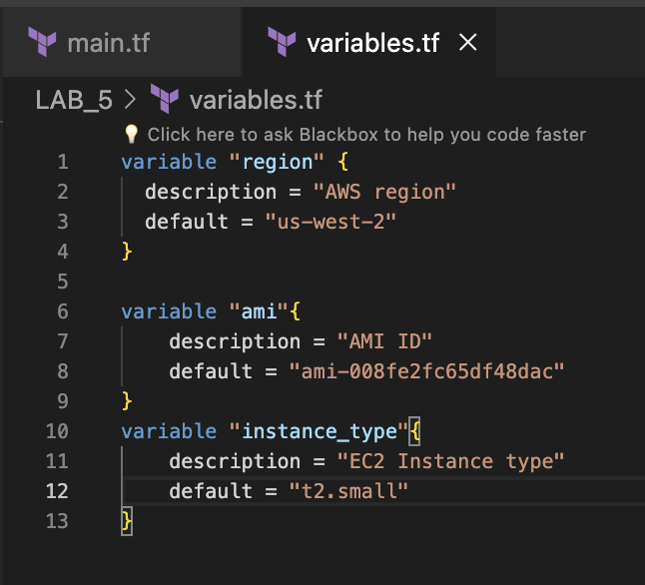

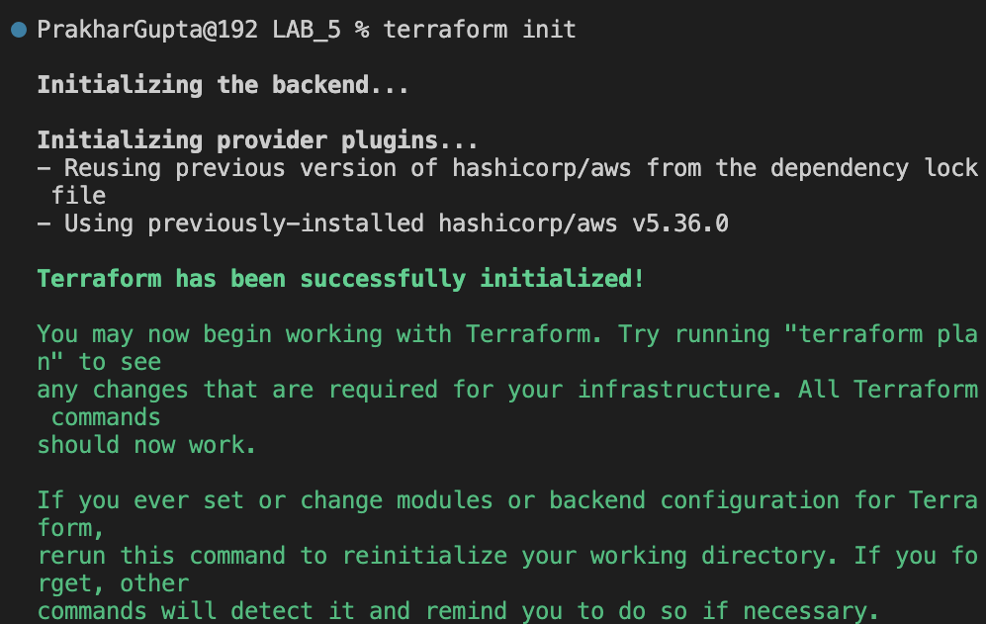

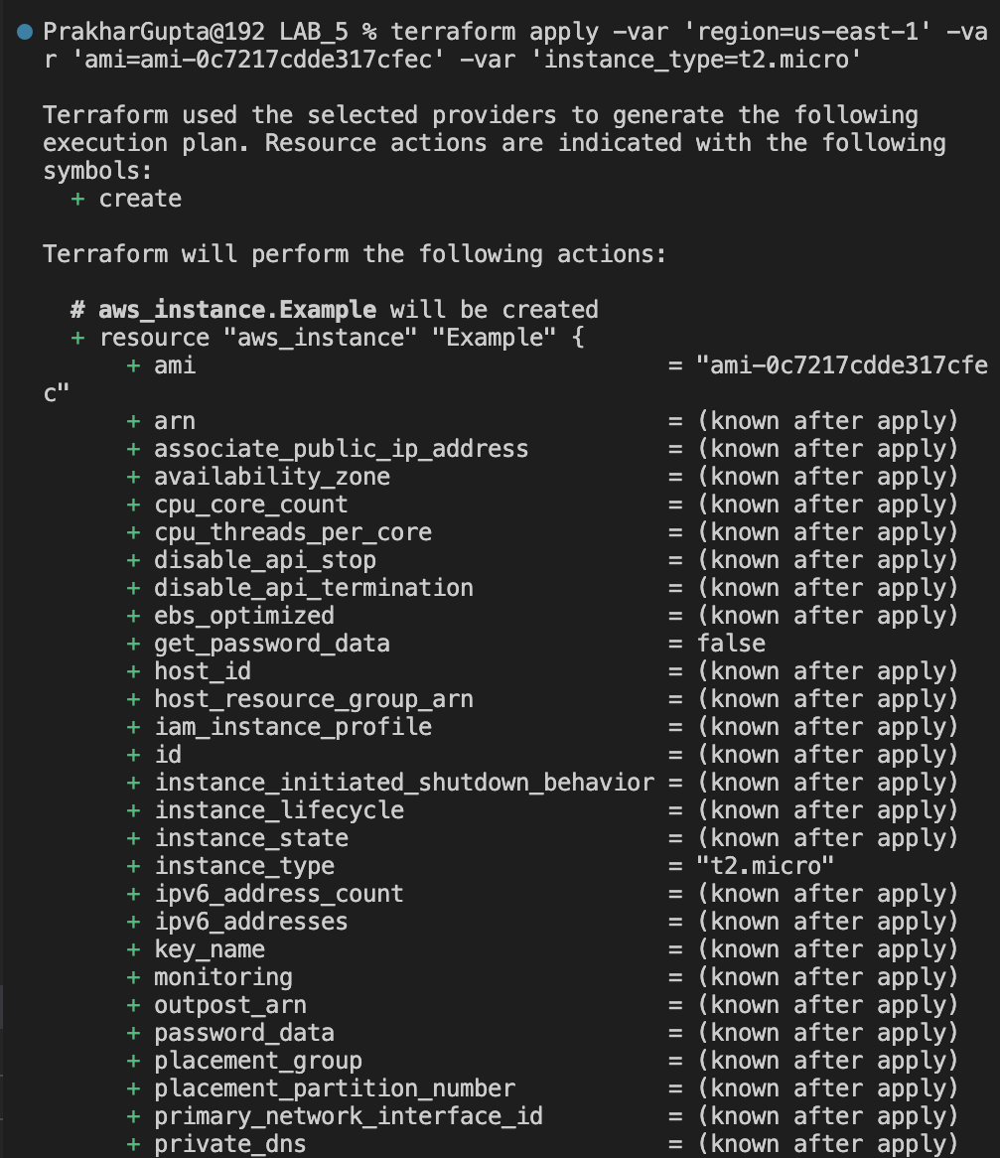

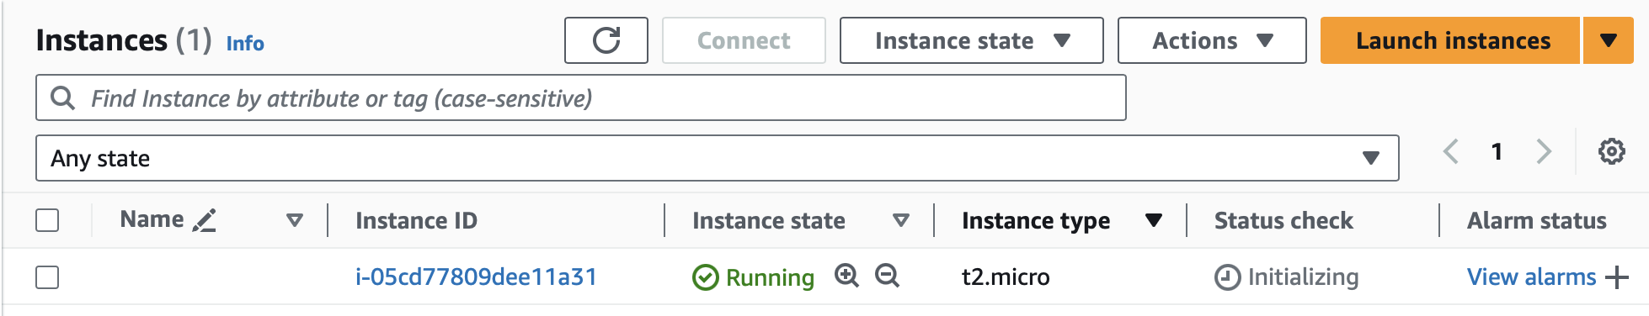

Clean Up: After testing, you can clean up resources:

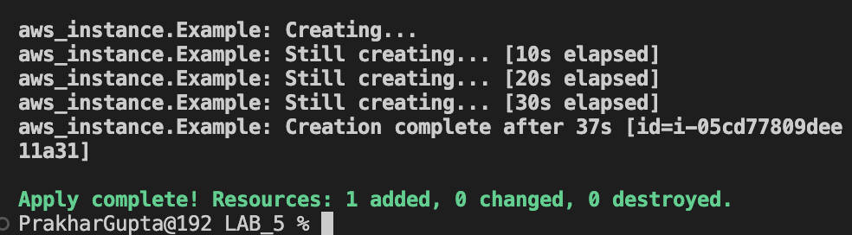

# LAB EXERCISE 6

## Aim: Terraform Multiple tfvars Files Objective:

Step 1: Create a main.tf file

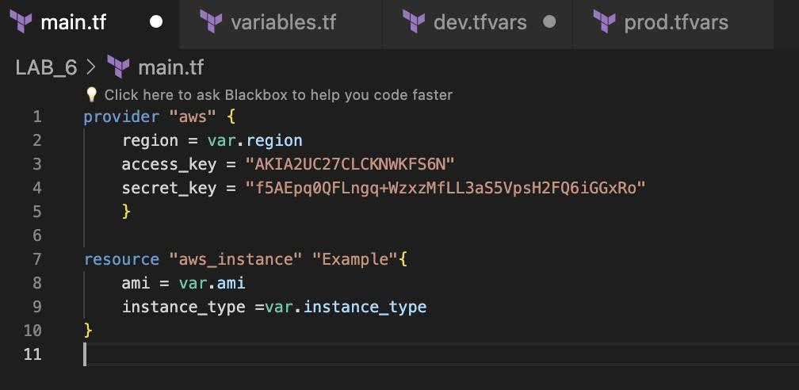

Step 2: Create a variable.tf file

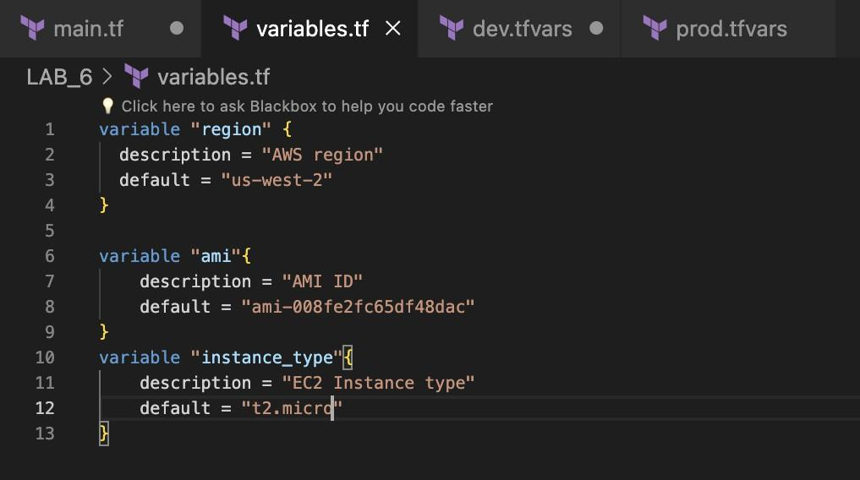

Step 3: Create Multiple tfvars Files: dev.tfvars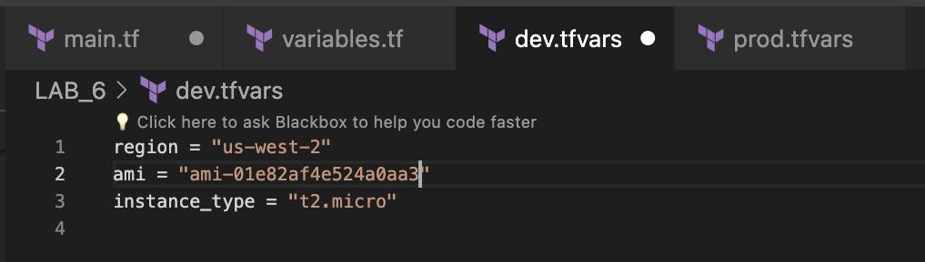

prod.tfvars

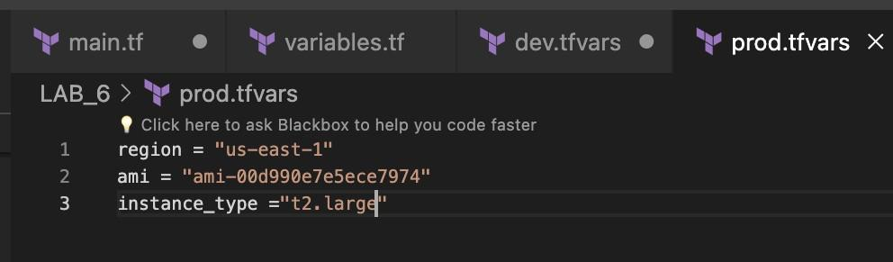

Step 4: Now initializes

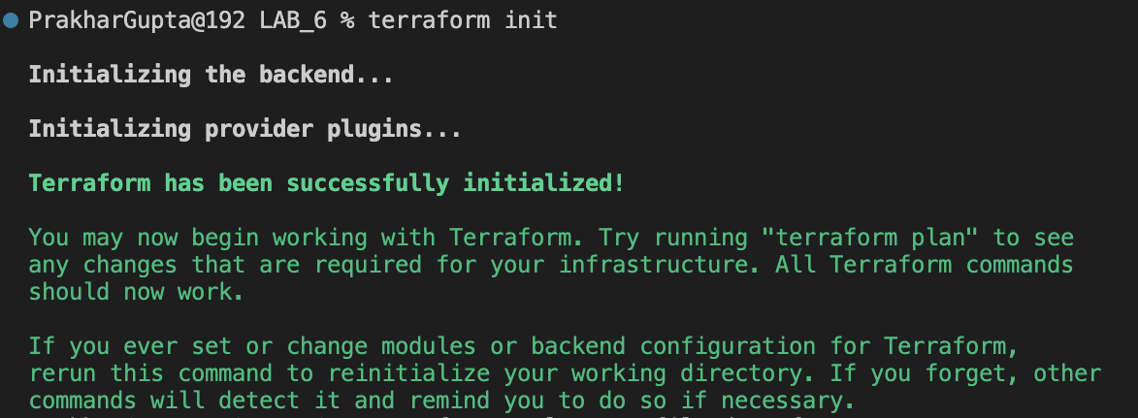

Step 5: Apply for Dev Environment

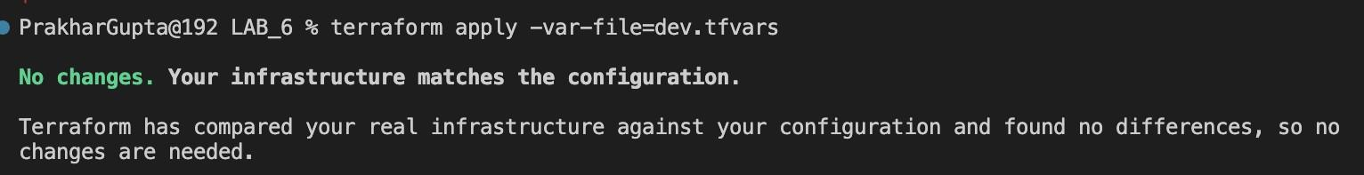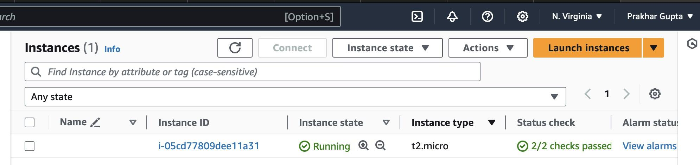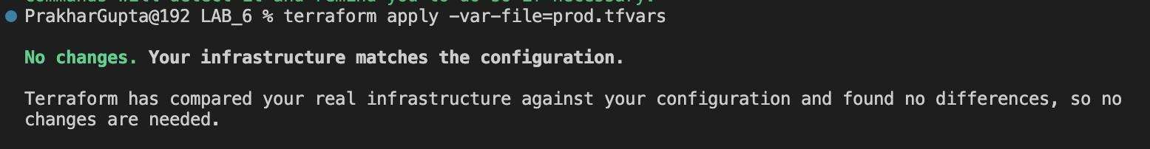

Step 6: Destroy Dev Environment

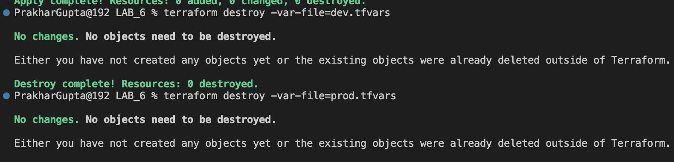

. **LAB EXERCISE 7**

**Aim:** Creating Multiple IAM Users in Terraform

Step 1: Create a main.tf file.

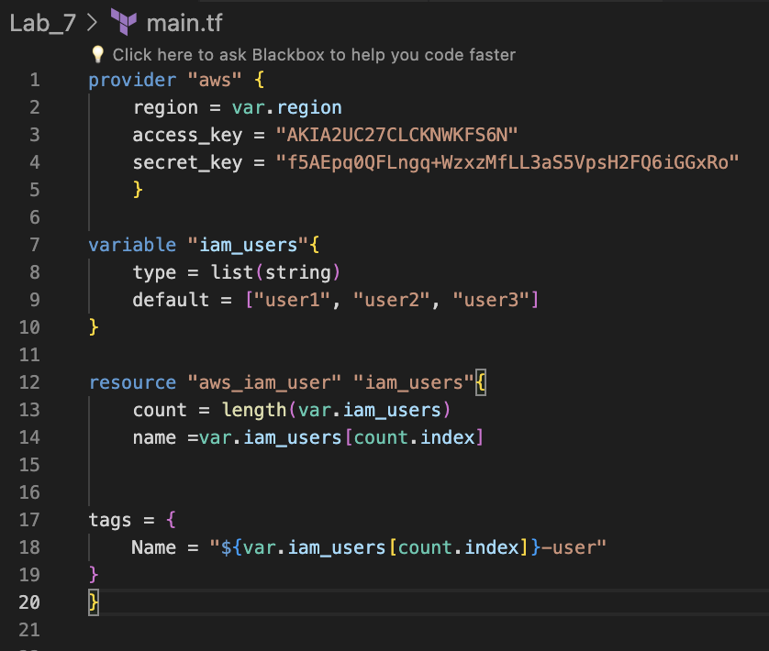

Step 2: Create a instance.tf file

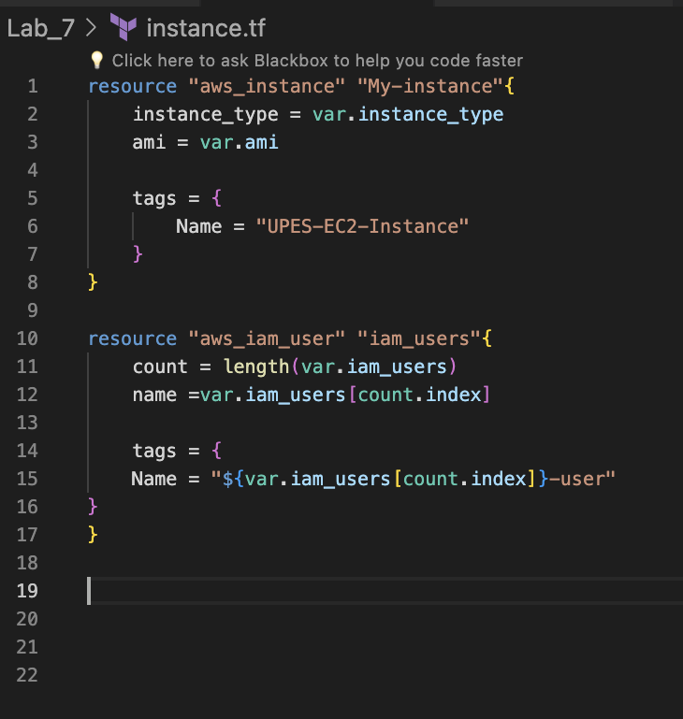

Step 3: Create a variable.tf file

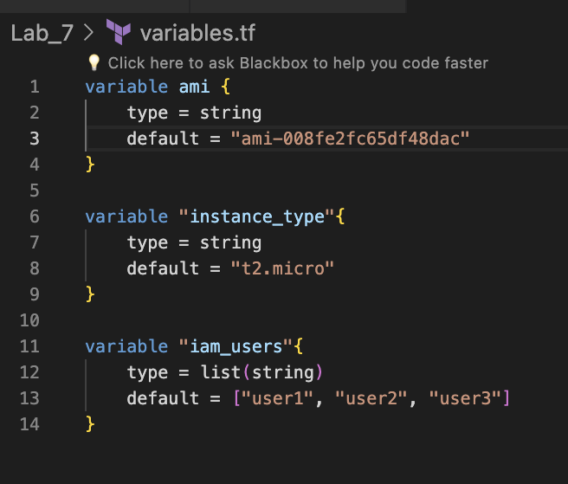

Step 4: Now initializes

Step 5: Now perform validate

Step 6: Now perform the terraform apply

Step 7: Now perform Terraform destroy

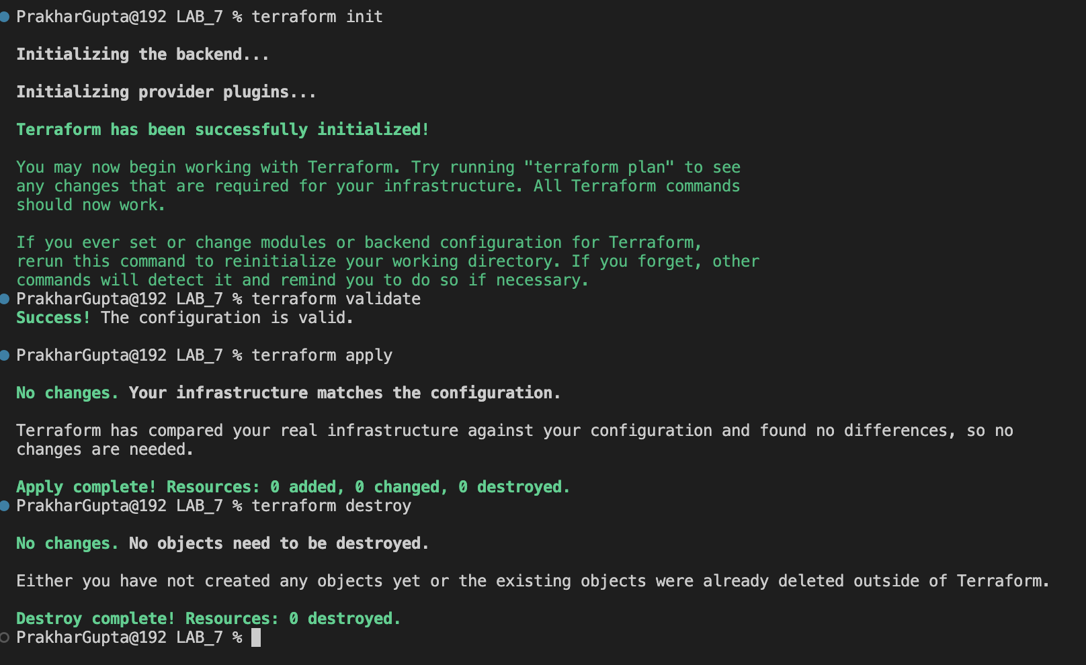

**LAB EXERCISE 8**

**Aim: Creating a VPC in Terraform Objective**

Step 1: Create a main.tf file

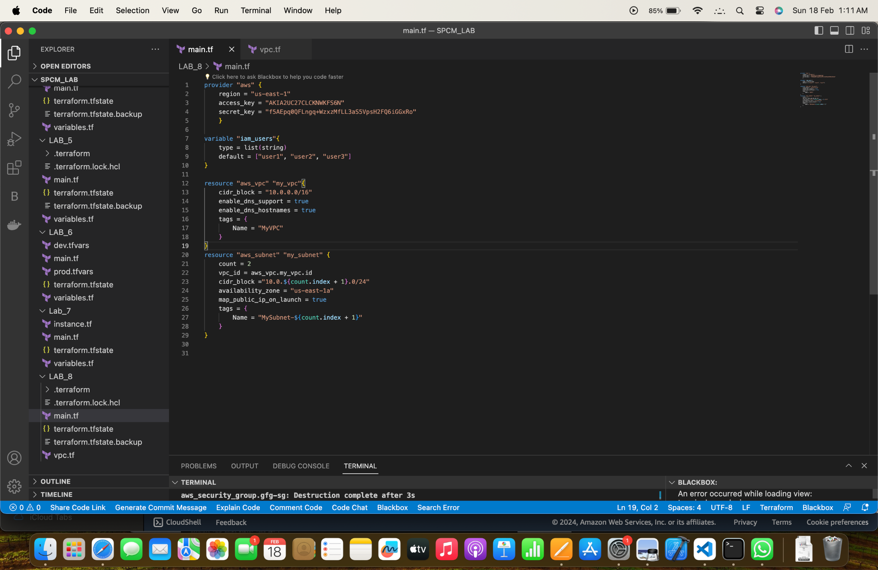

Step 2: Create a vpc.tf file

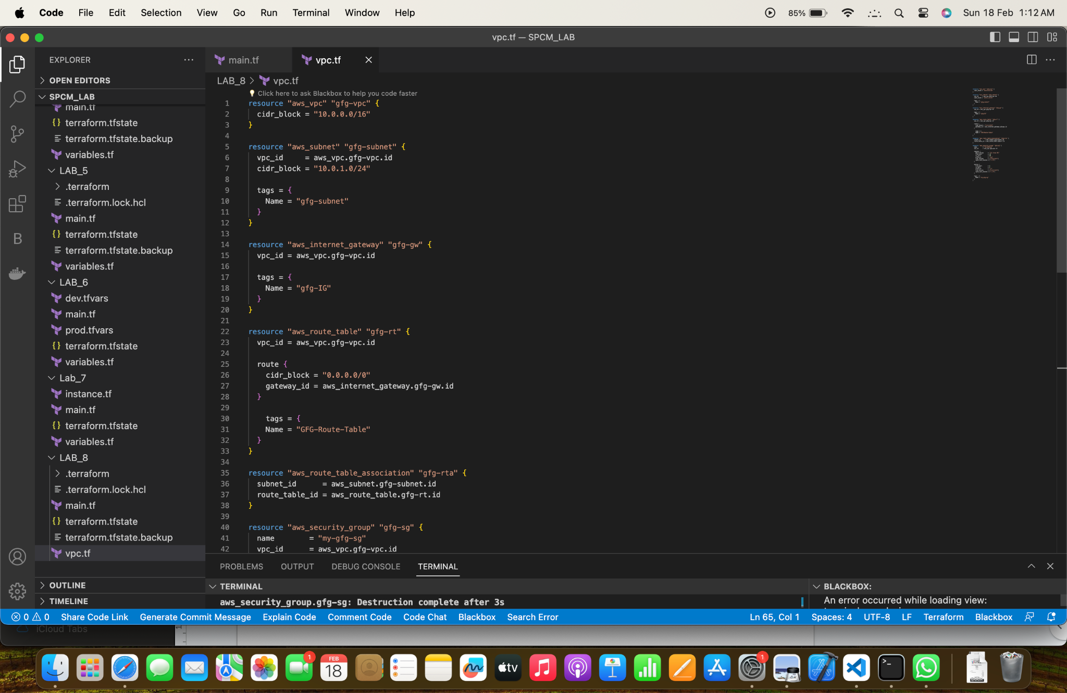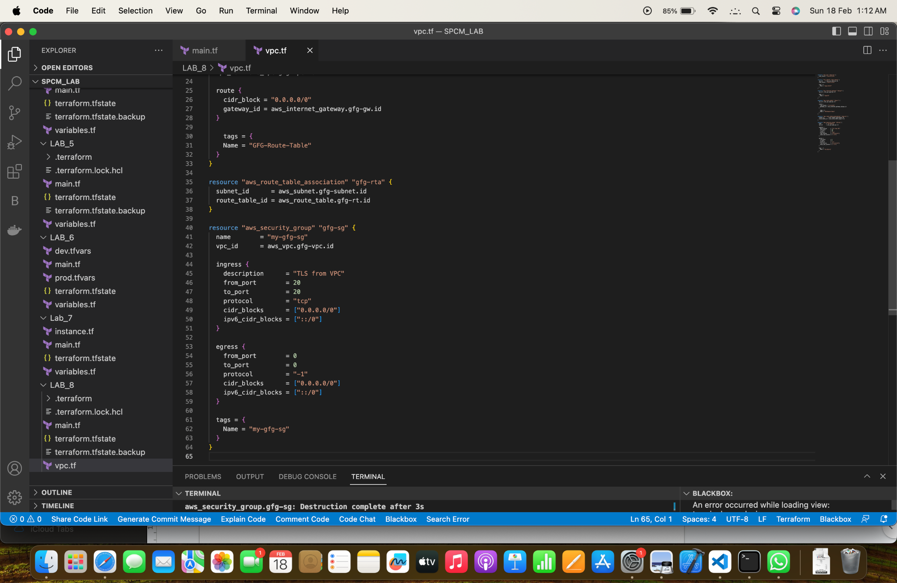

Step 3: Now run terraform init command to Initialize.

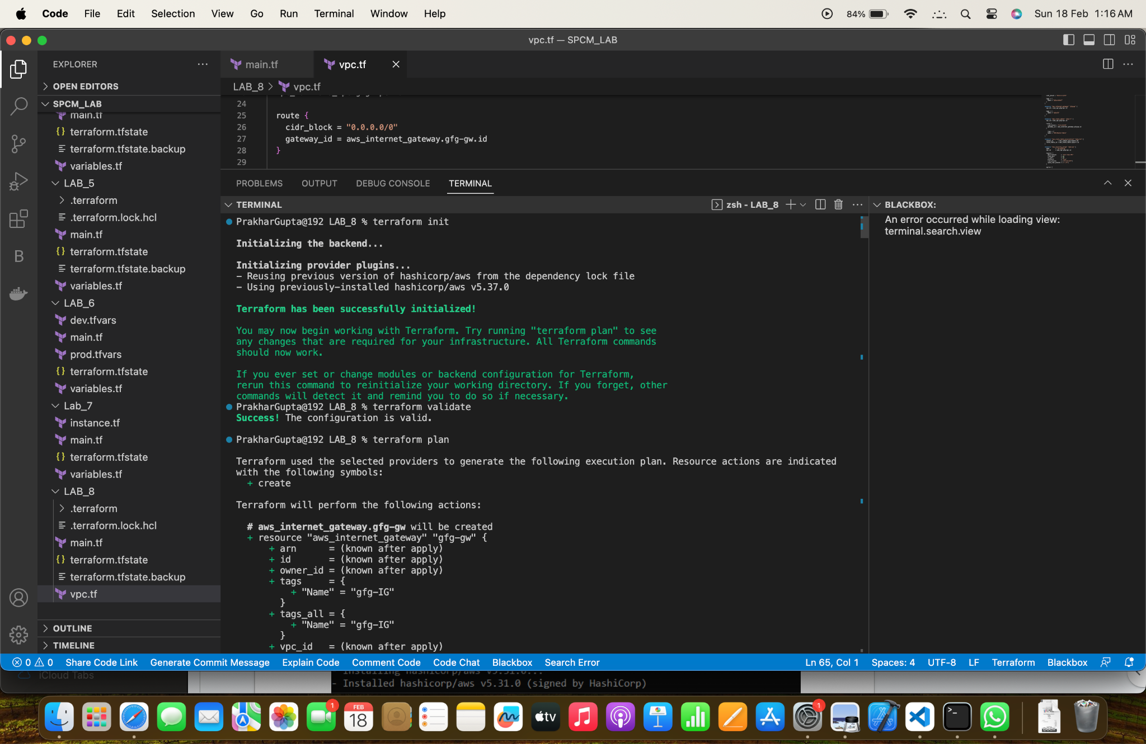

Step 5: Now run terraform plan command

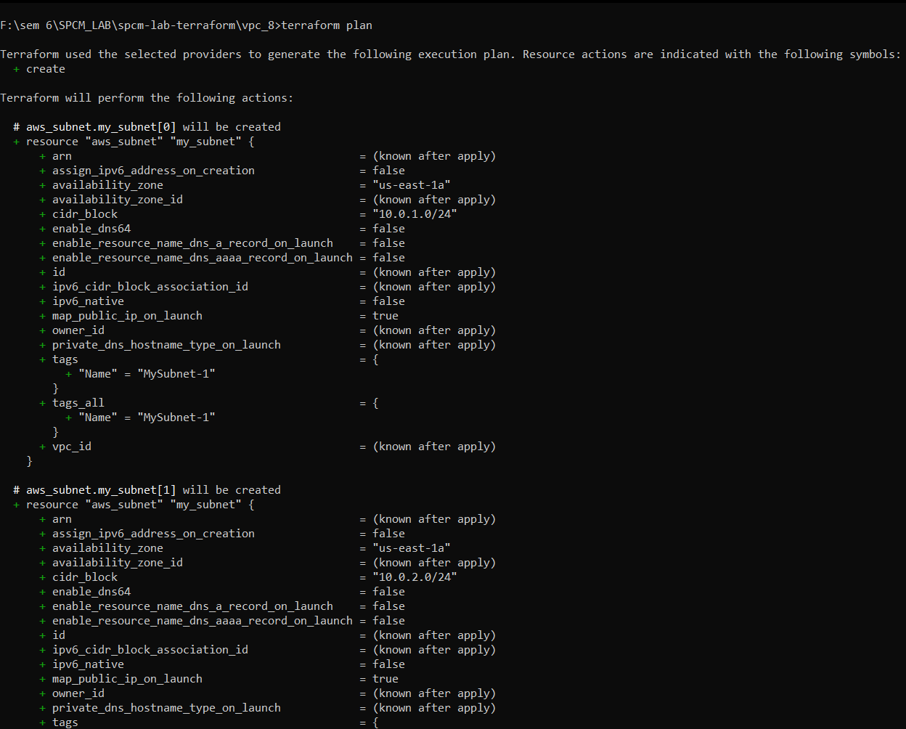

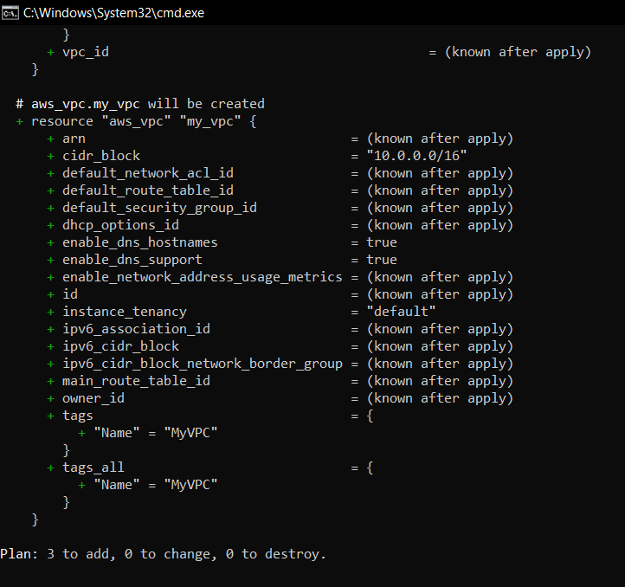

Step 6: Now run the terraform apply command.

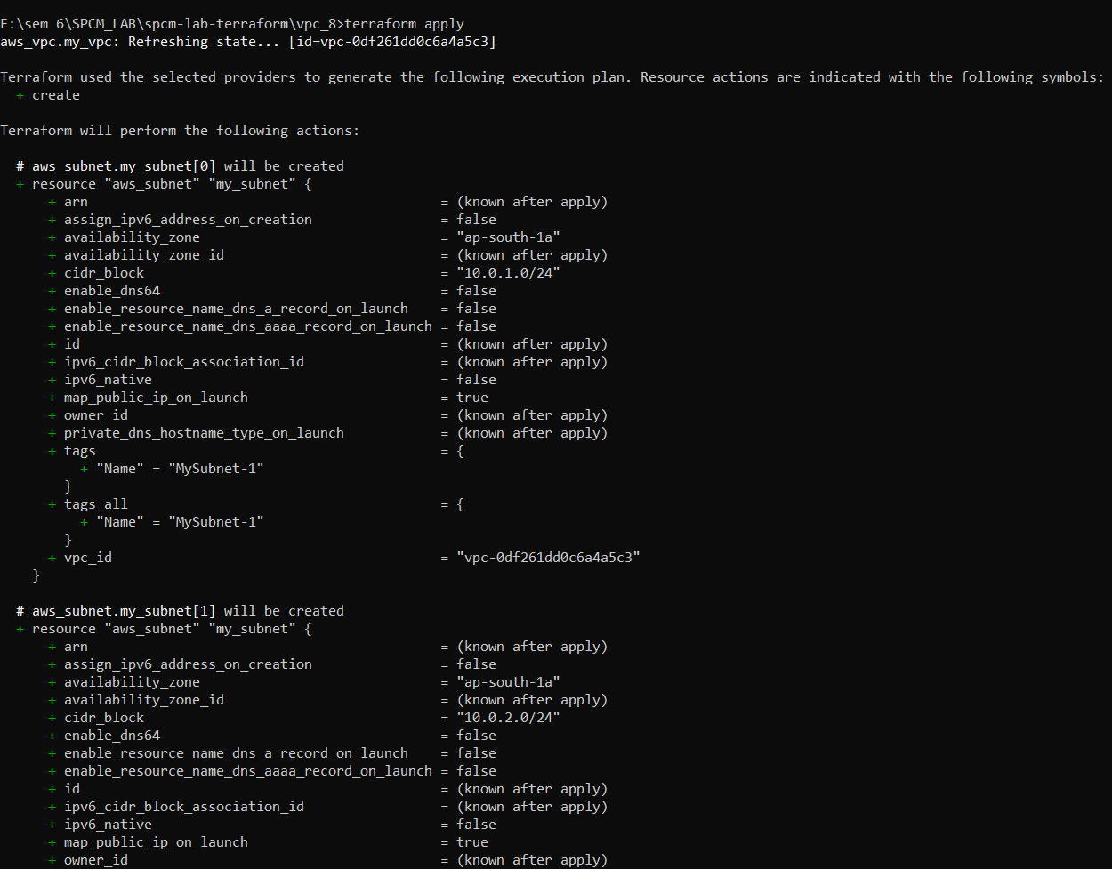

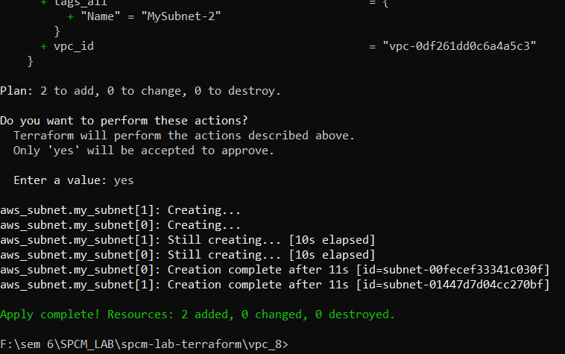

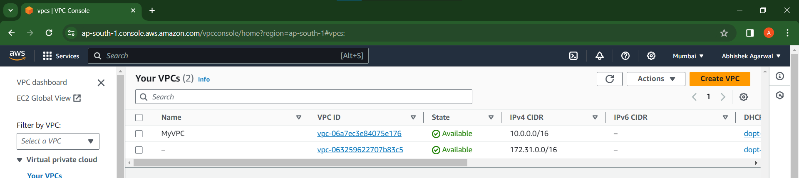

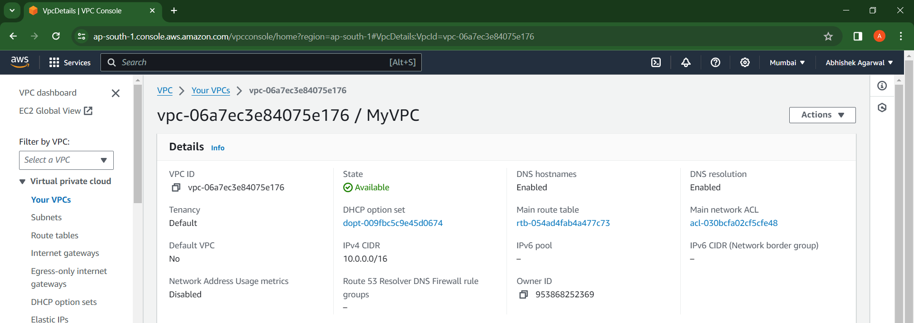

Step 7: Now run the terraform destroy to destroy the VPC created.

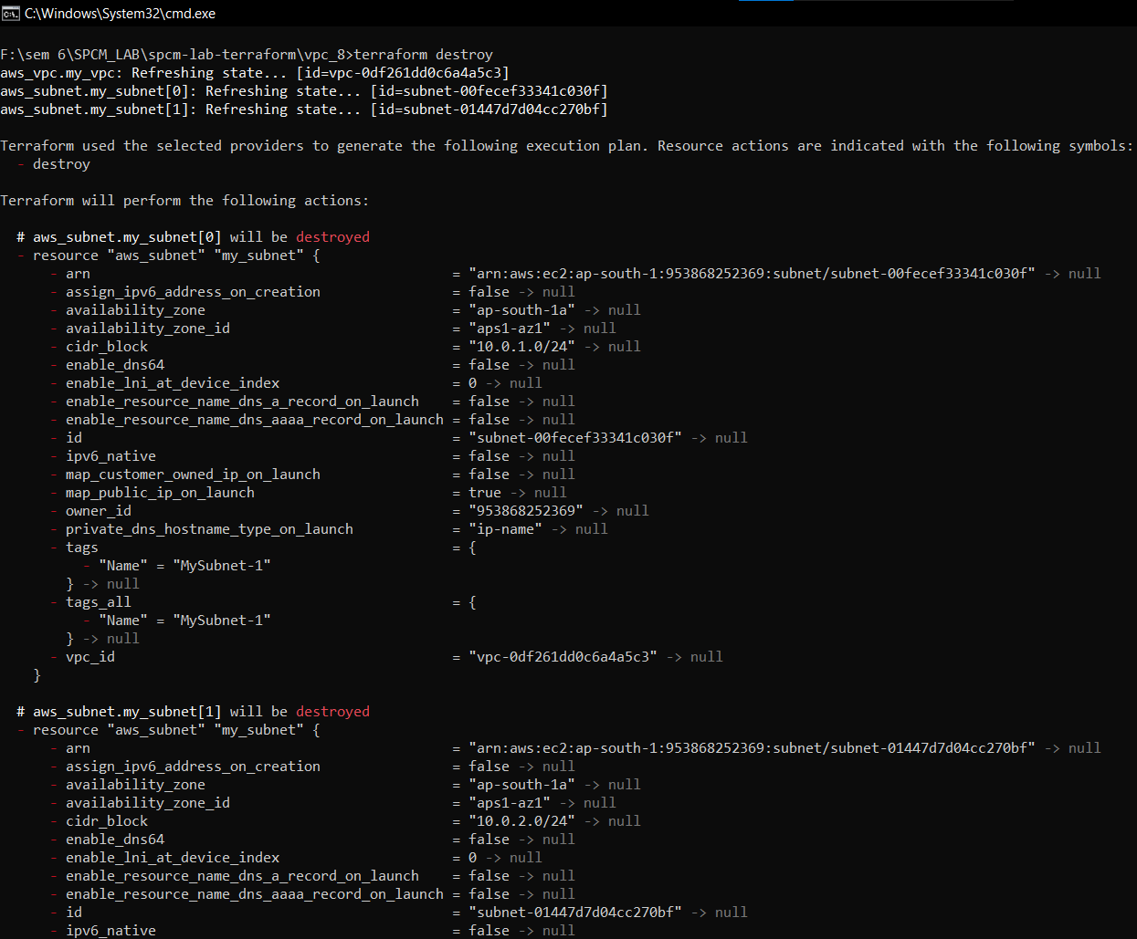

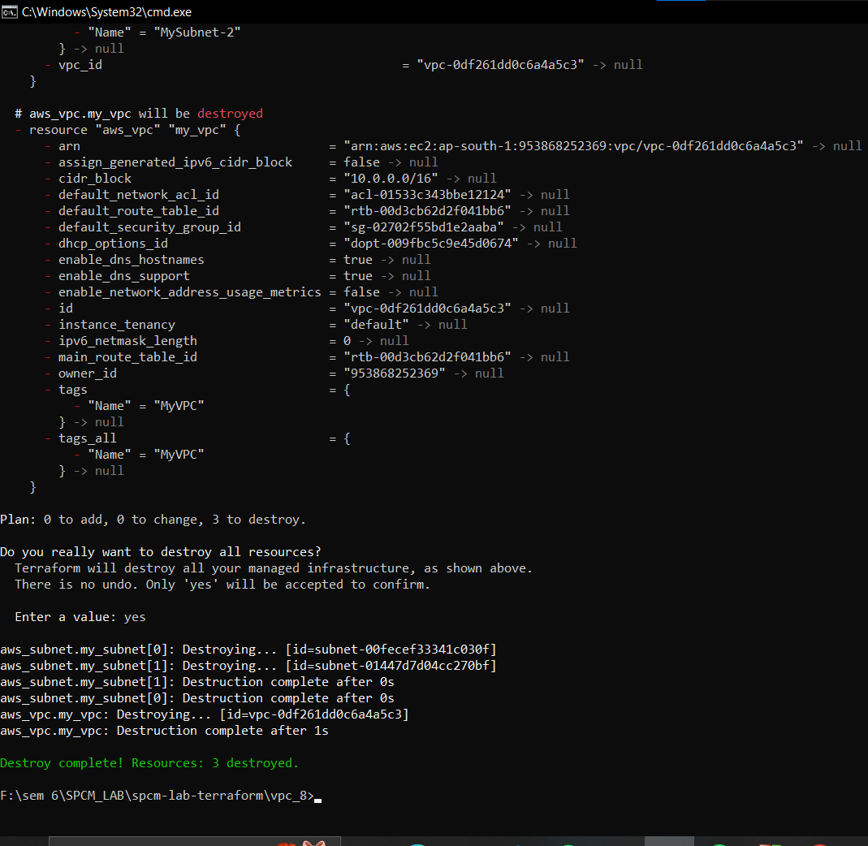

Step 8: Now update the vpc.tf file.

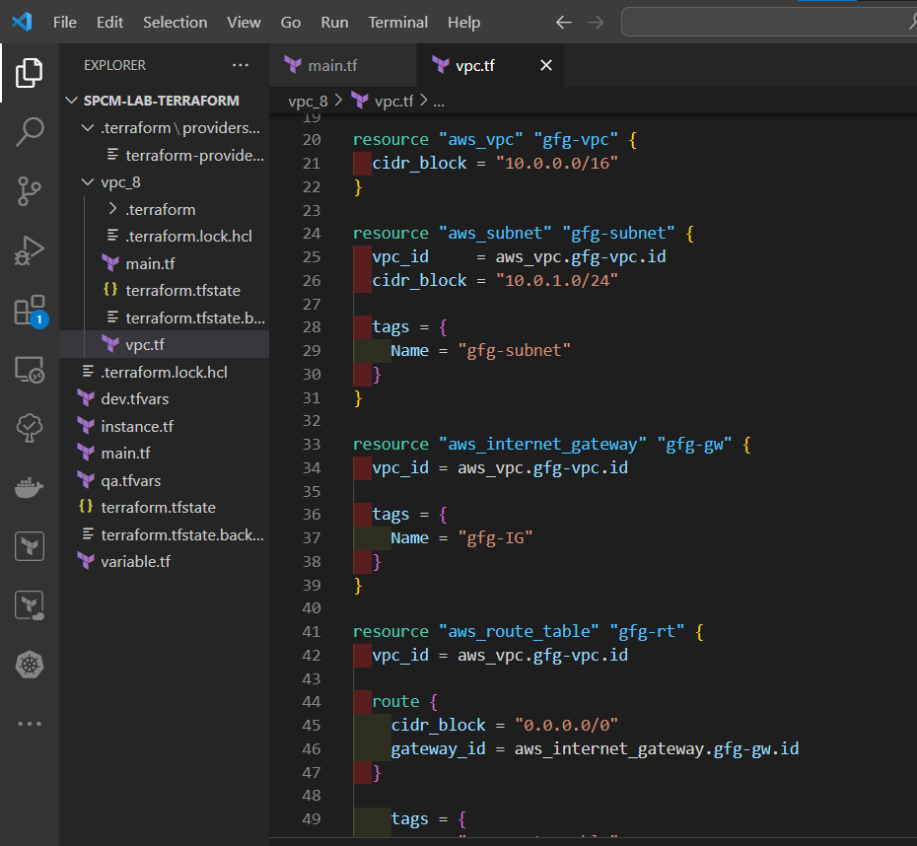

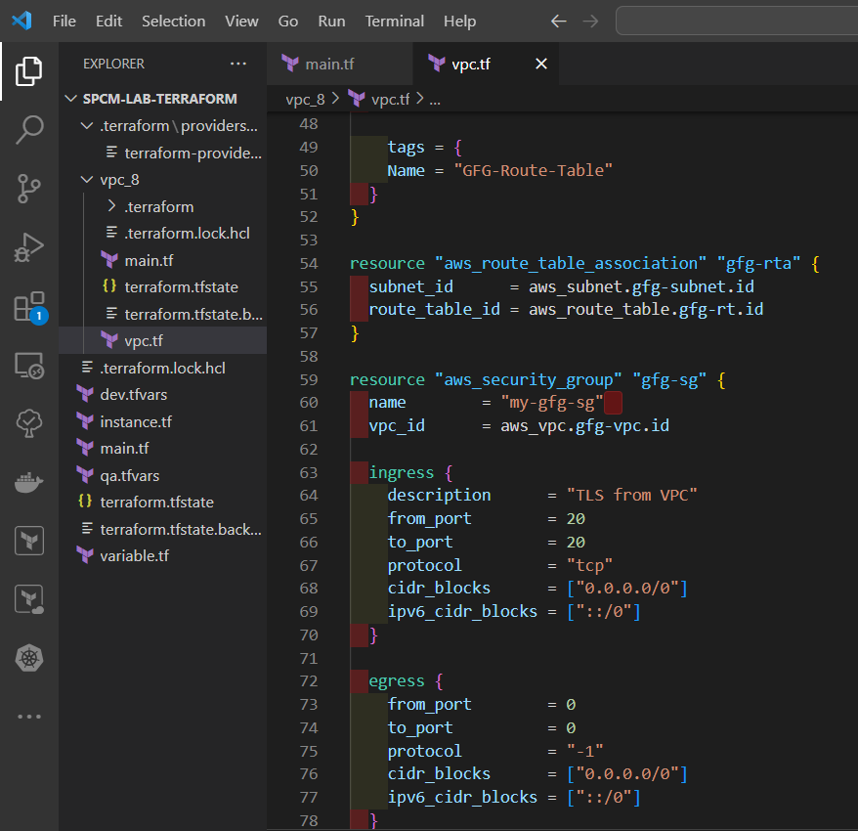

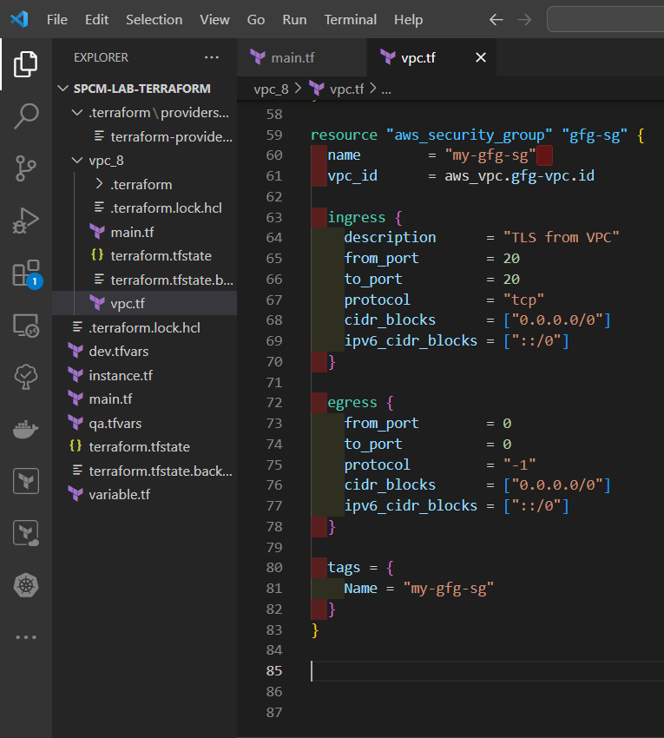

Step 9: Now again run the terraform run and validate command.

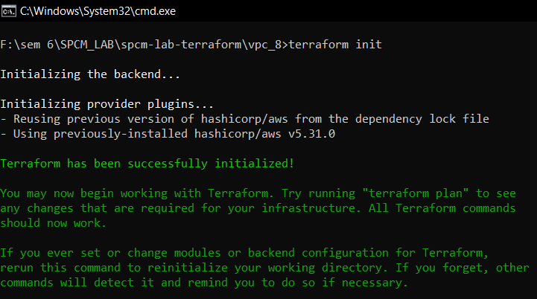

Step 10: Now again run the terraform plan command.

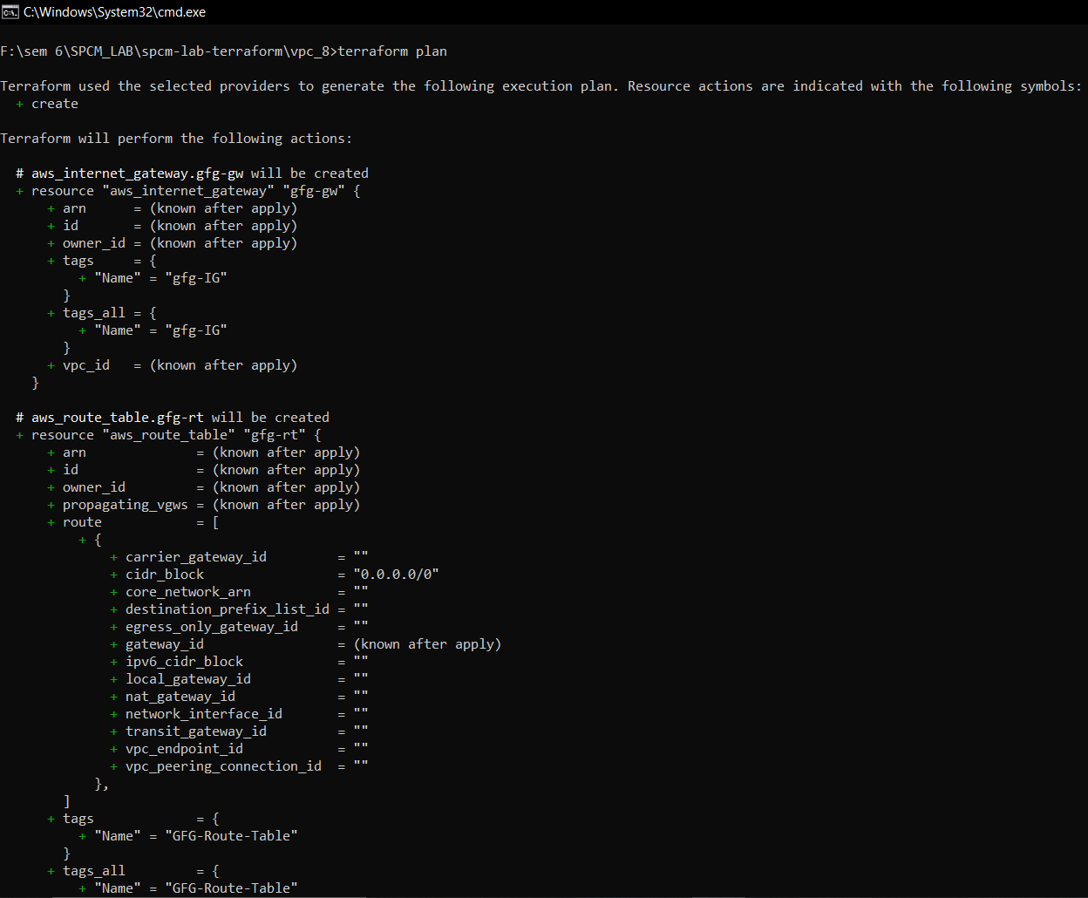

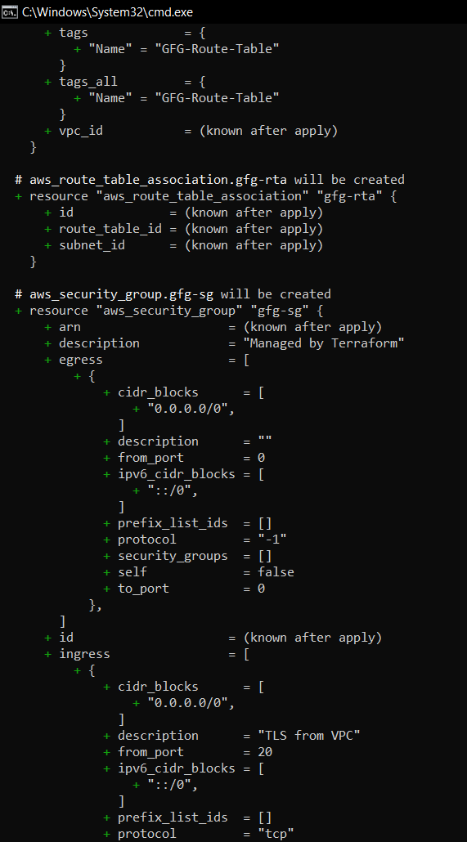

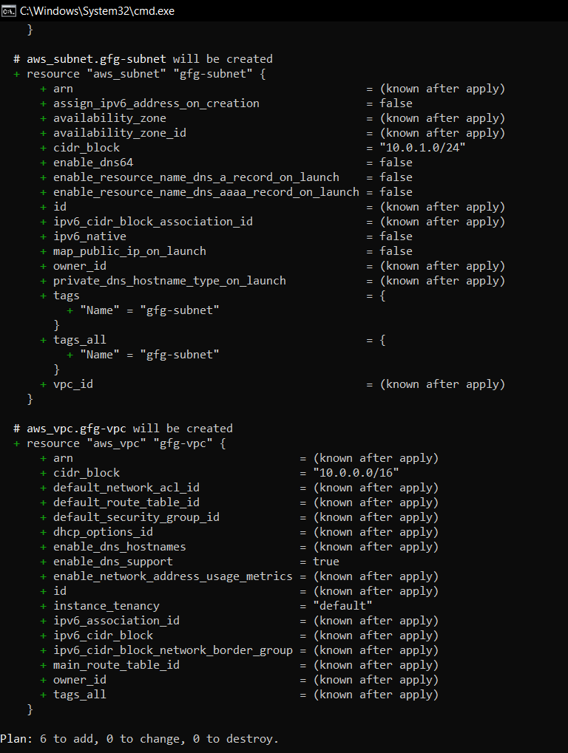

Step 11: Now run the terraform apply command.

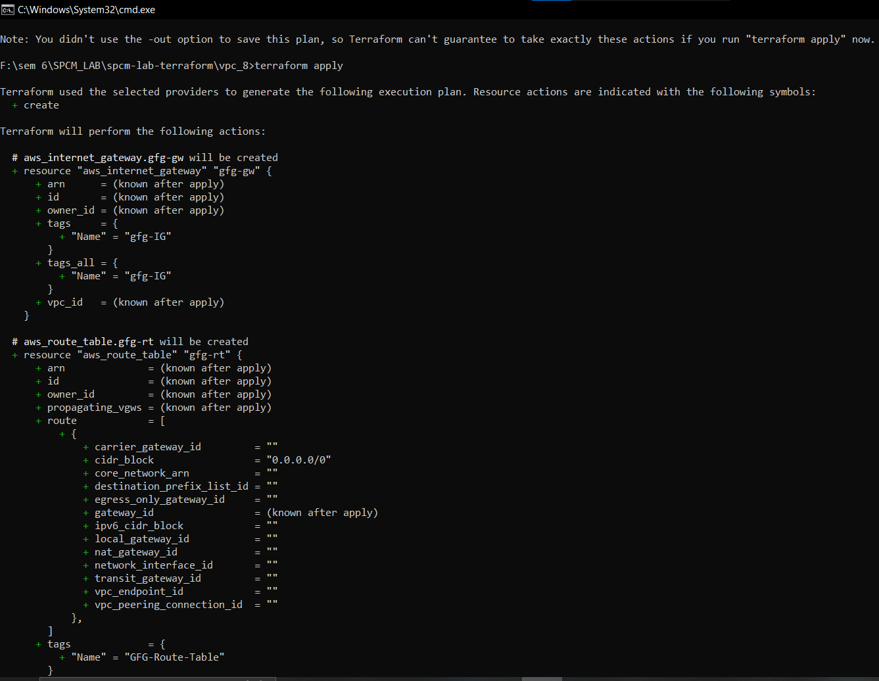

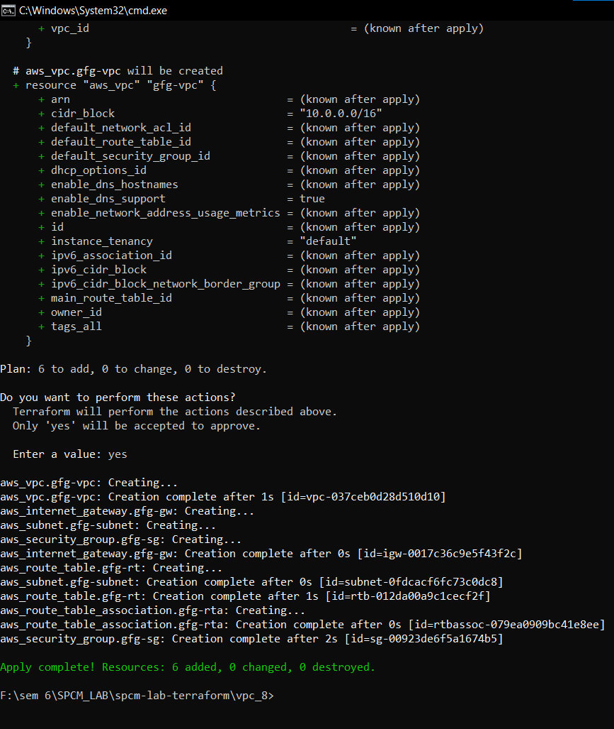

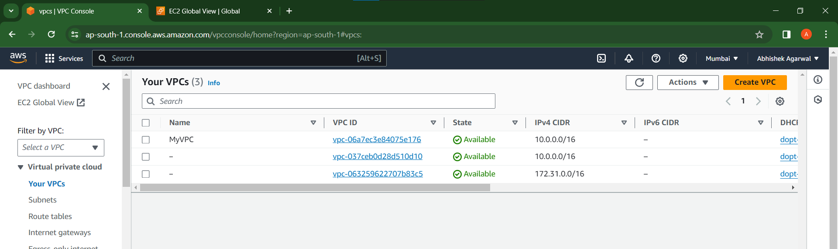

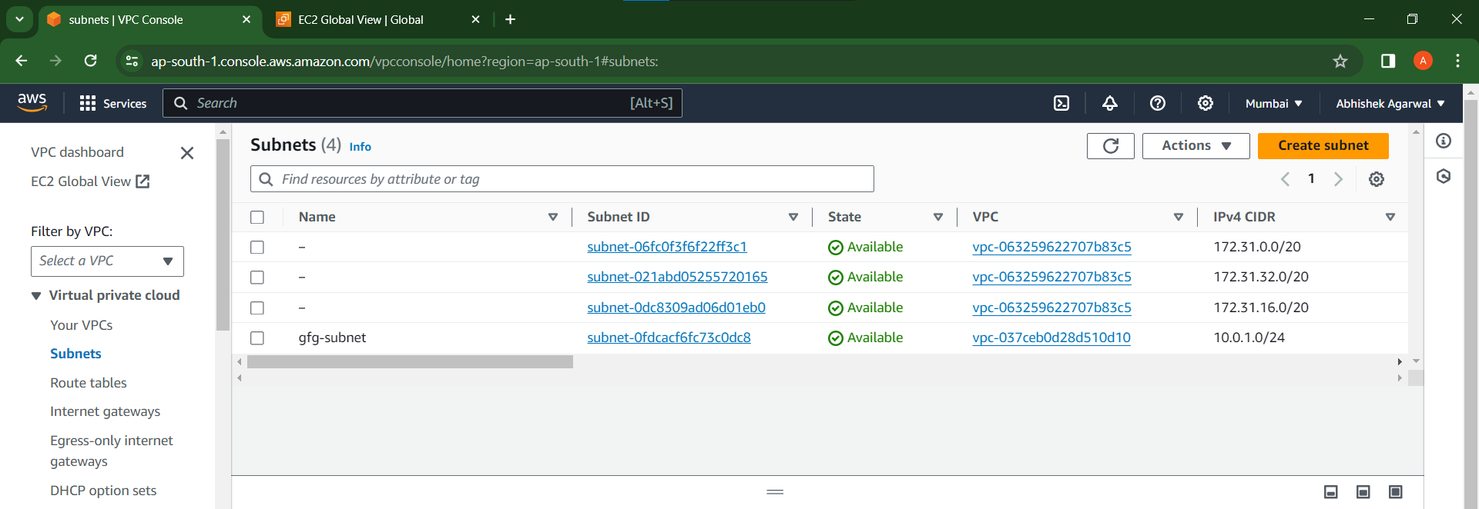

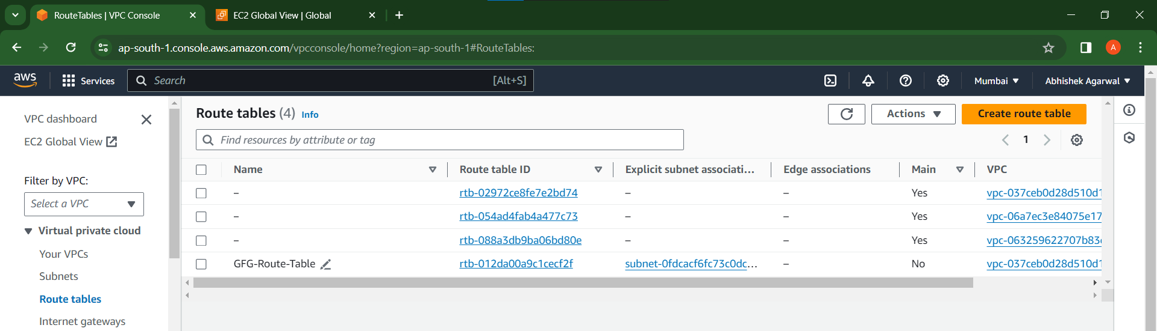

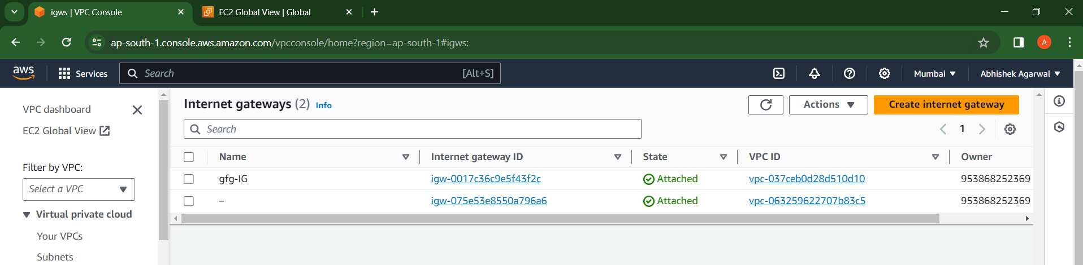

Step 12: Now run terraform destroy command.

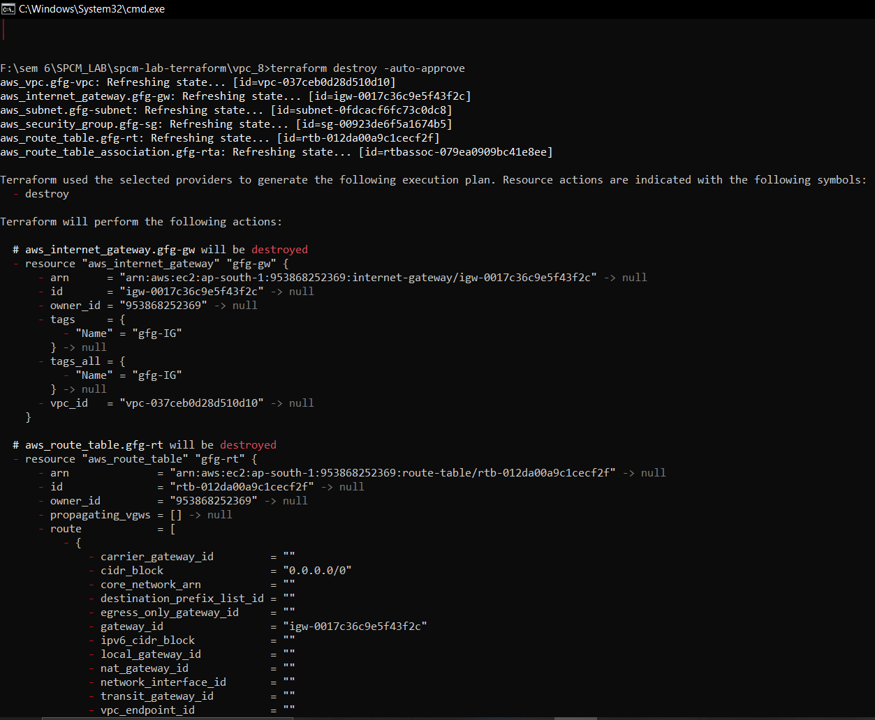

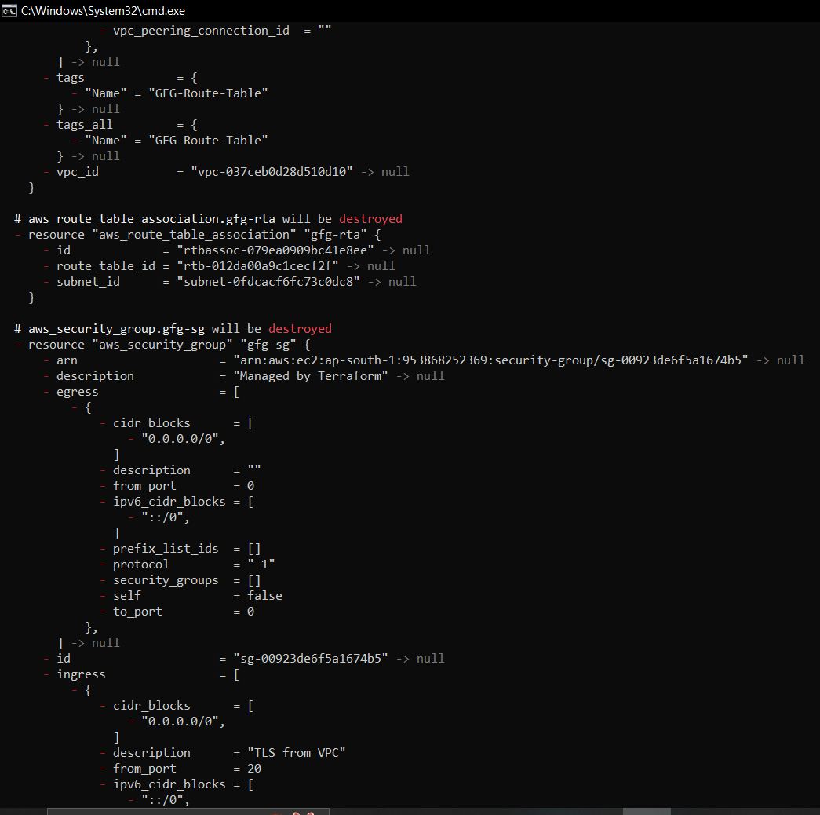

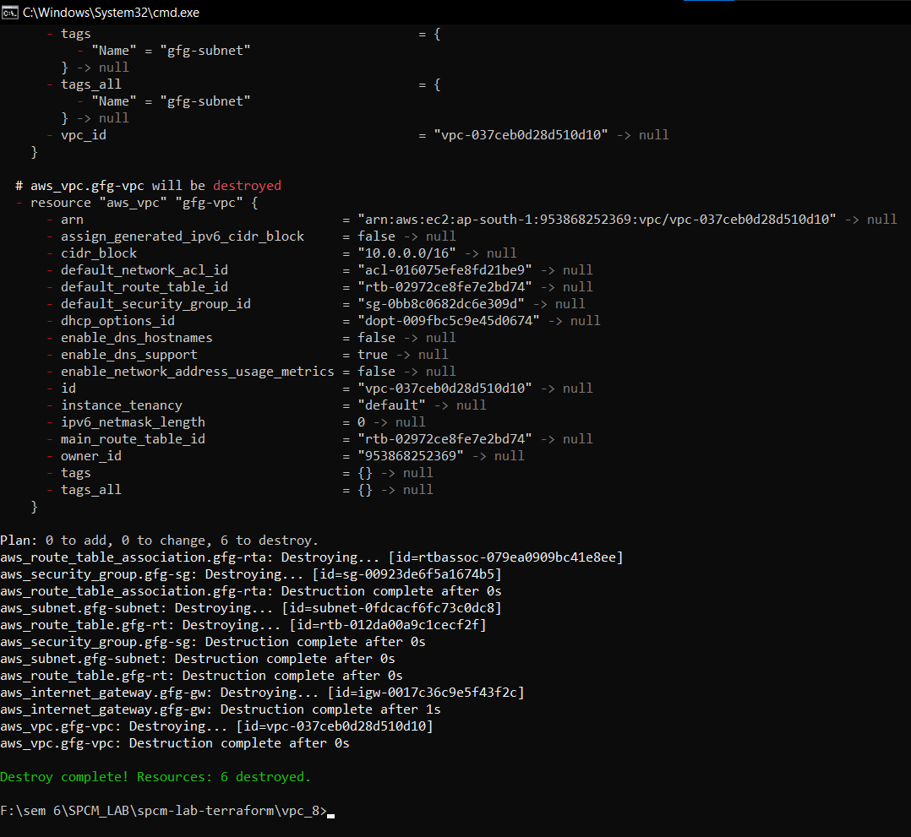

**LAB EXERCISE 9**

**Aim: Creating Multiple EC2 Instances with for each in Terraform**

Step 1: Create a main.tf file

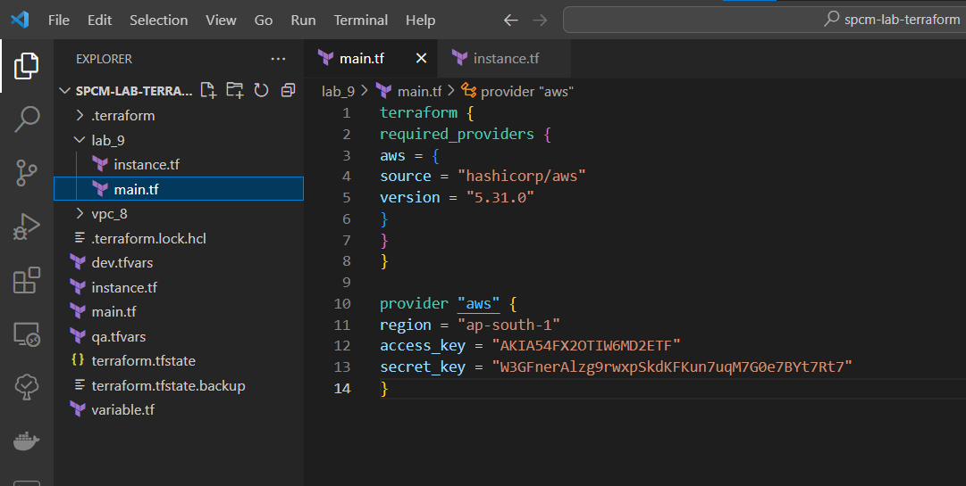

Step 2: Create a instance.tf file

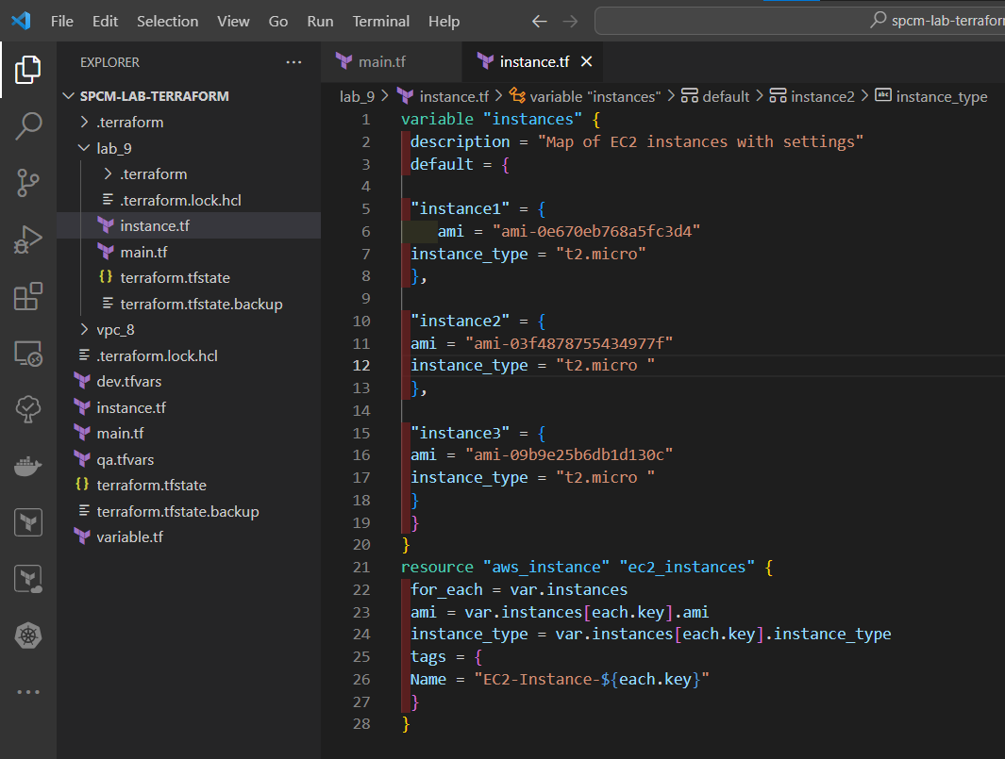

Step 3: Now run terraform init command to Initialize.

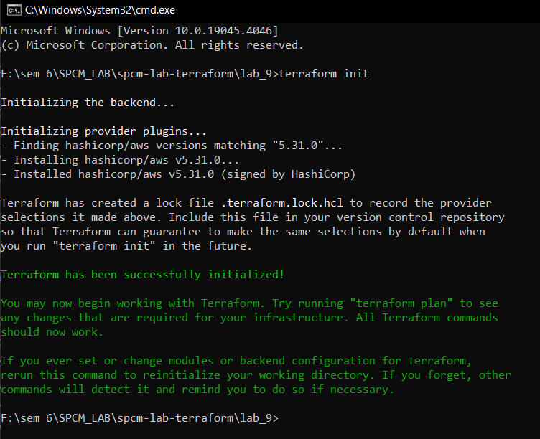

Step 4: Now run the terraform validate command to check if any error is present or not.

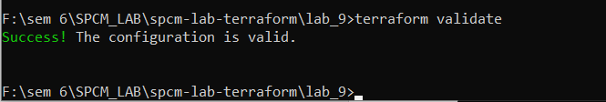

Step 5: Now run terraform plan command.

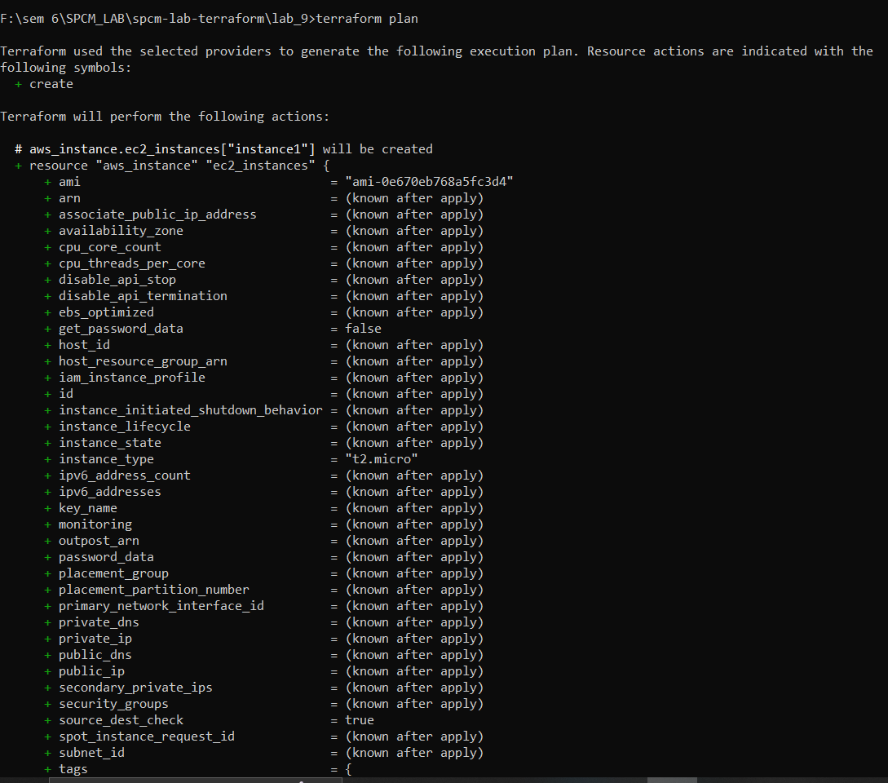

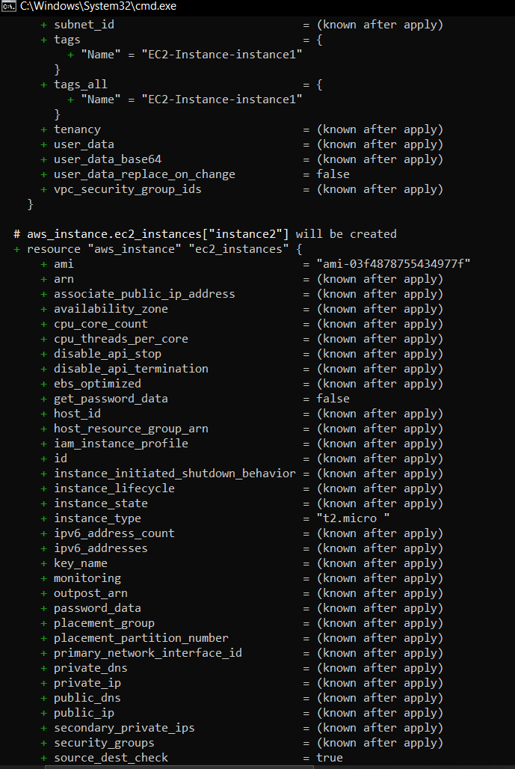

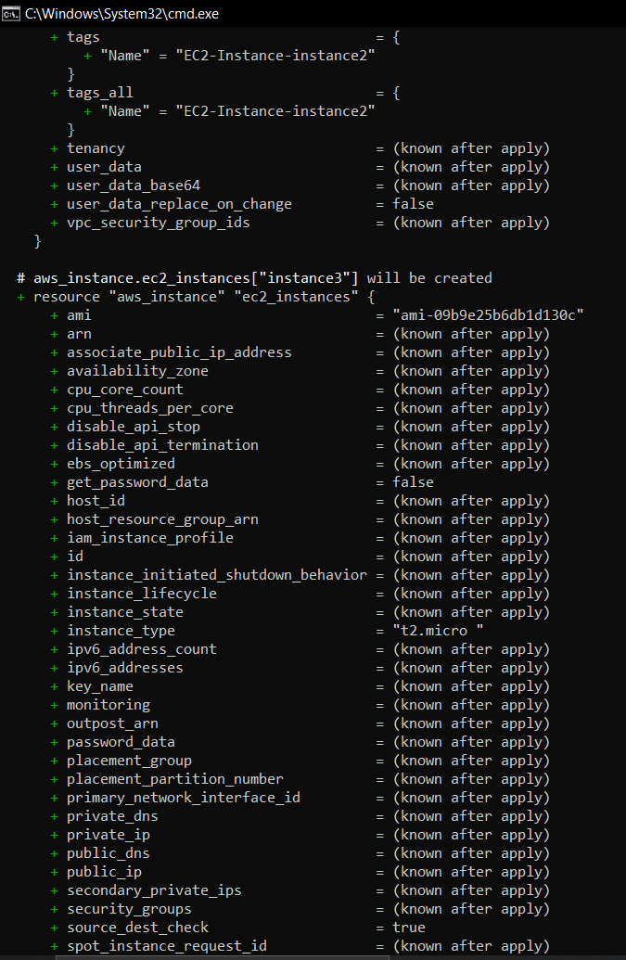

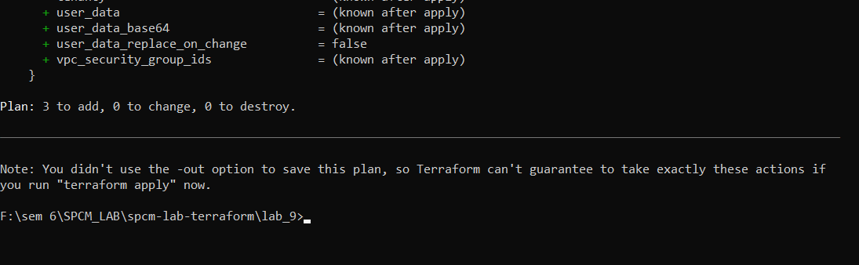

**LAB EXERCISE 10**

**Aim: Creating an AWS RDS Instance in Terraform**

Step 1: Create a main.tf file

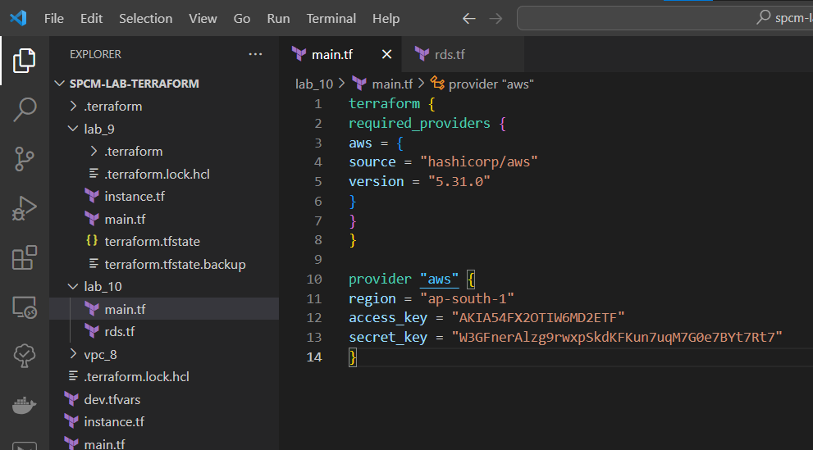

Step 2: Create a rds.tf file

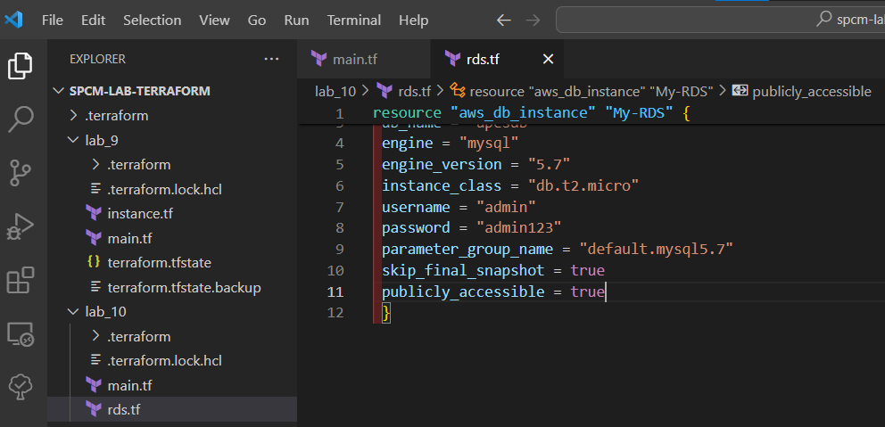

Step 3: Now run terraform init command to Initialize.

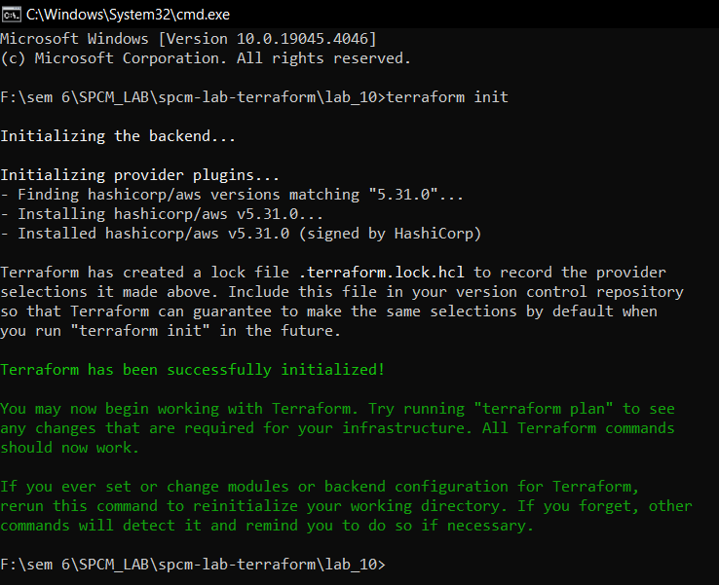

Step 4: Now run the terraform validate command to check if any error is present or not.

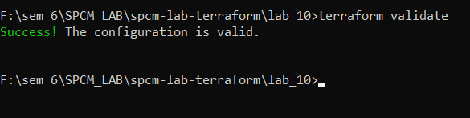

Step 5: Now run terraform plan command.

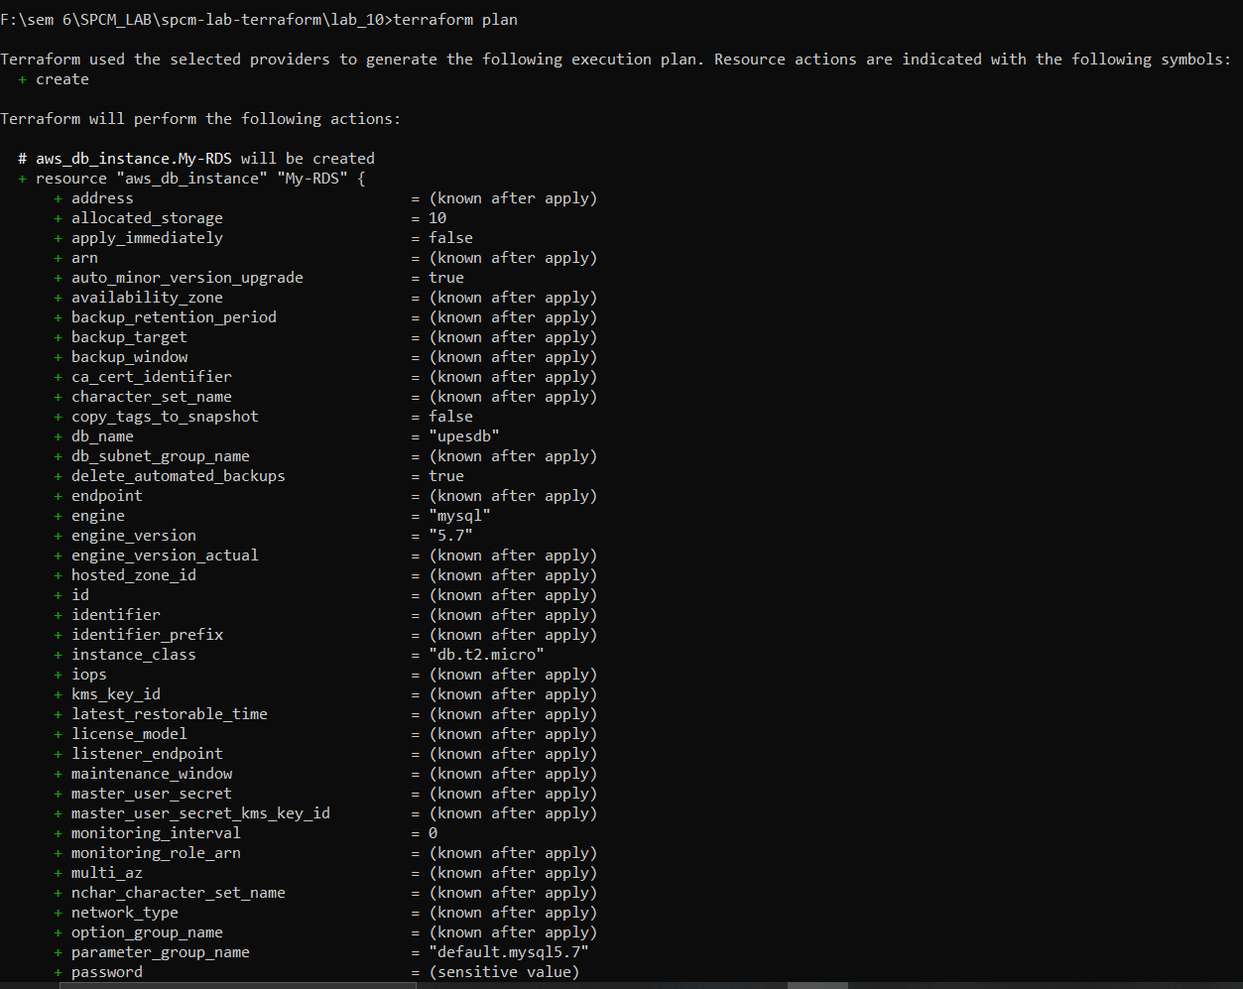

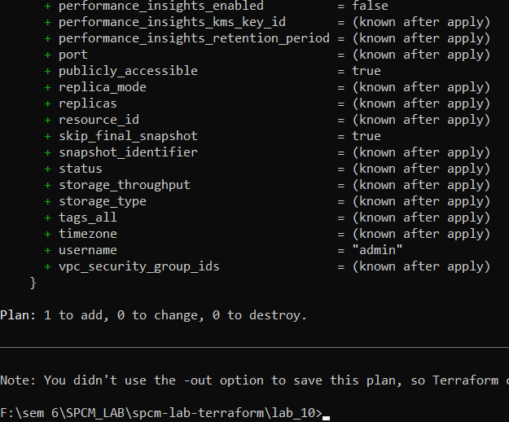

Step 6: Now run the terraform apply command to apply the rds.

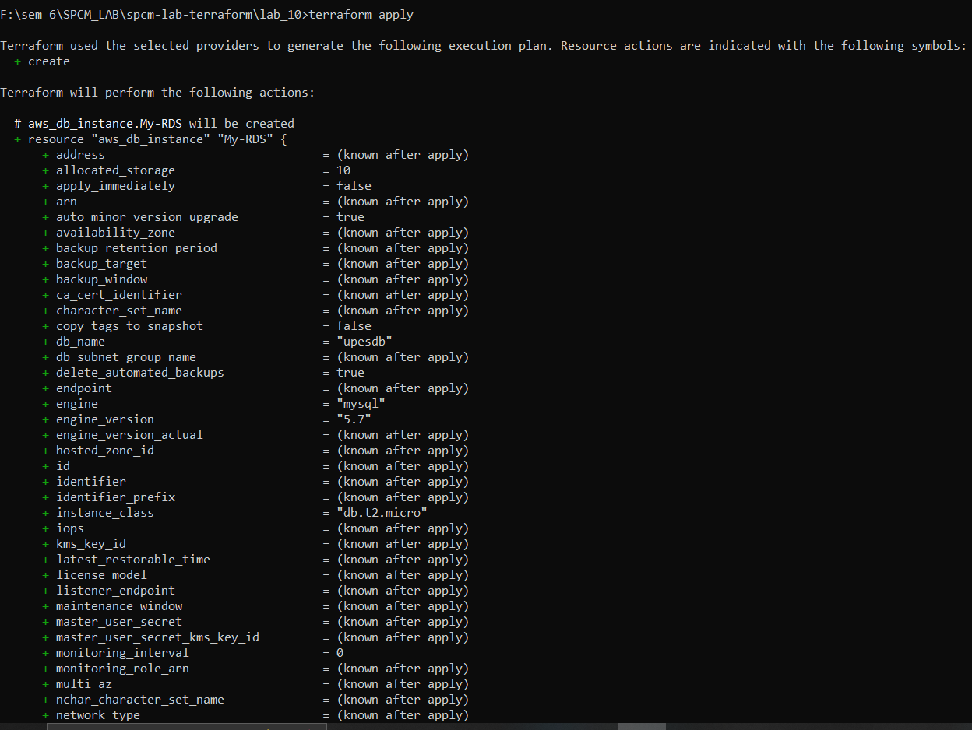

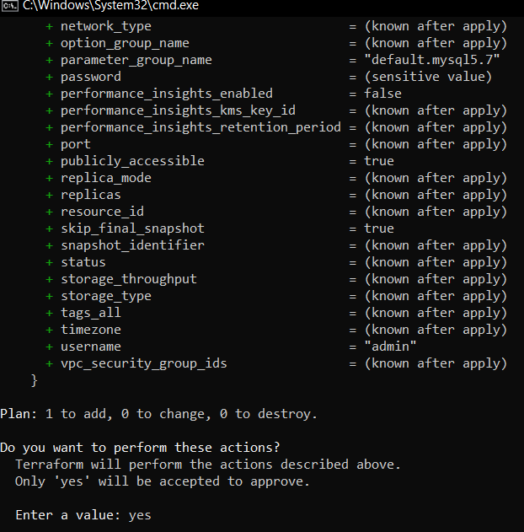

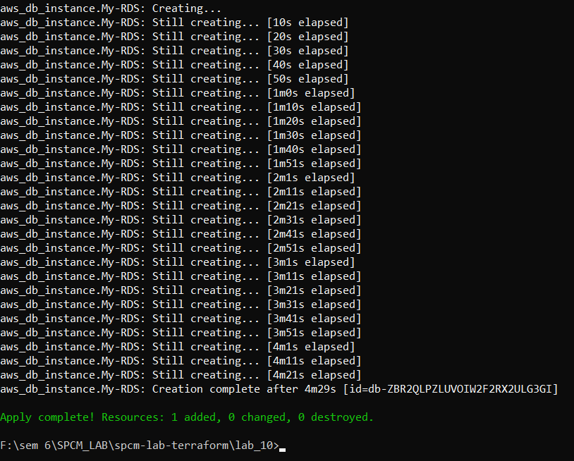

Step 7: Verify the RDS Instance in AWS Console.

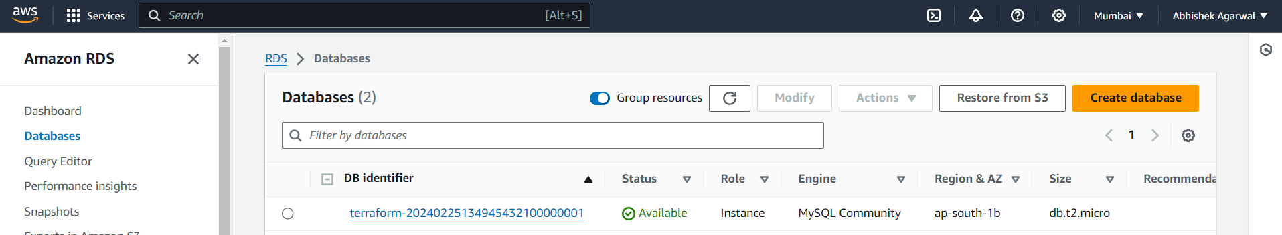

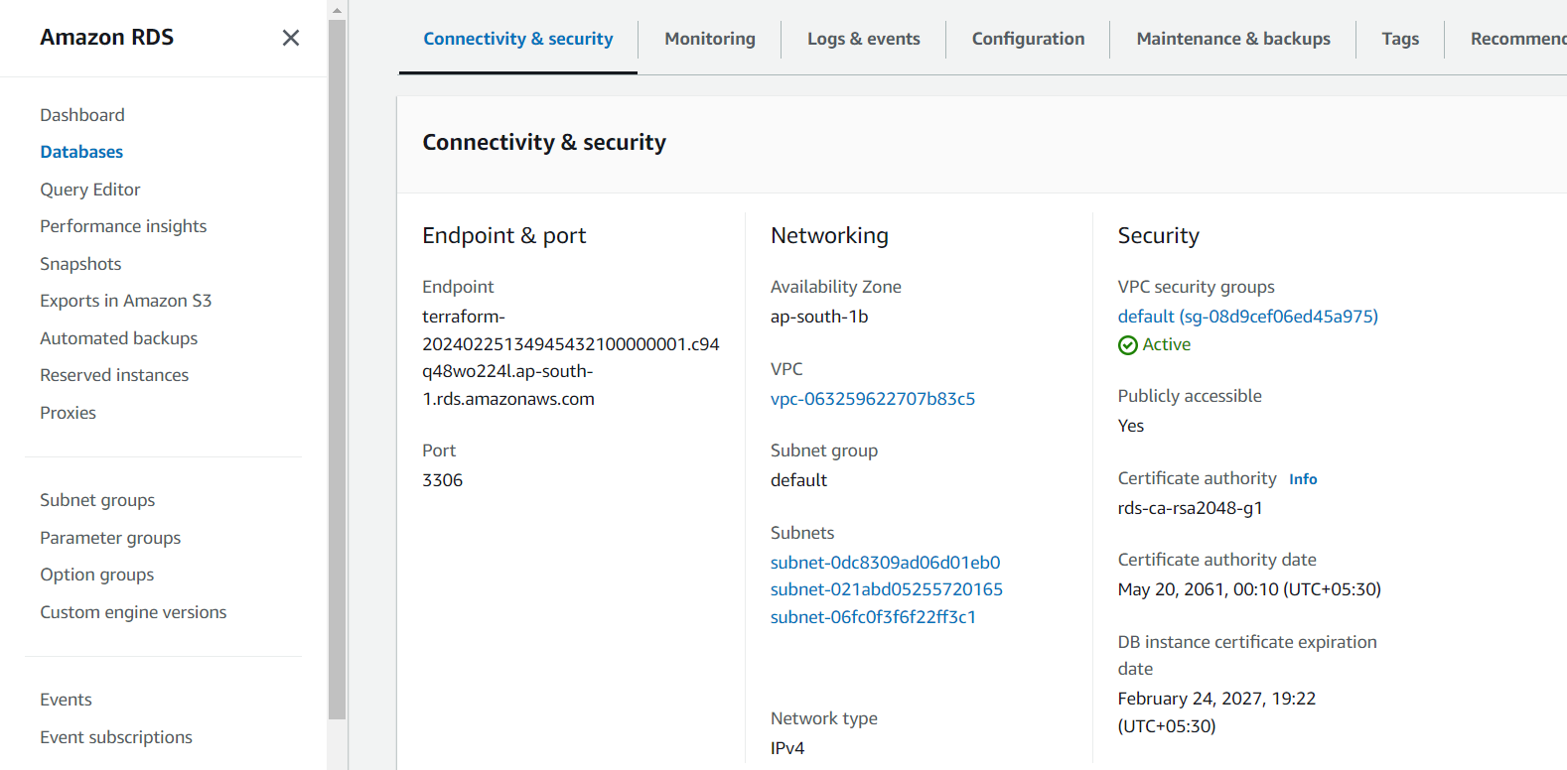

Step 8: Connect To MYSQL Workbench.

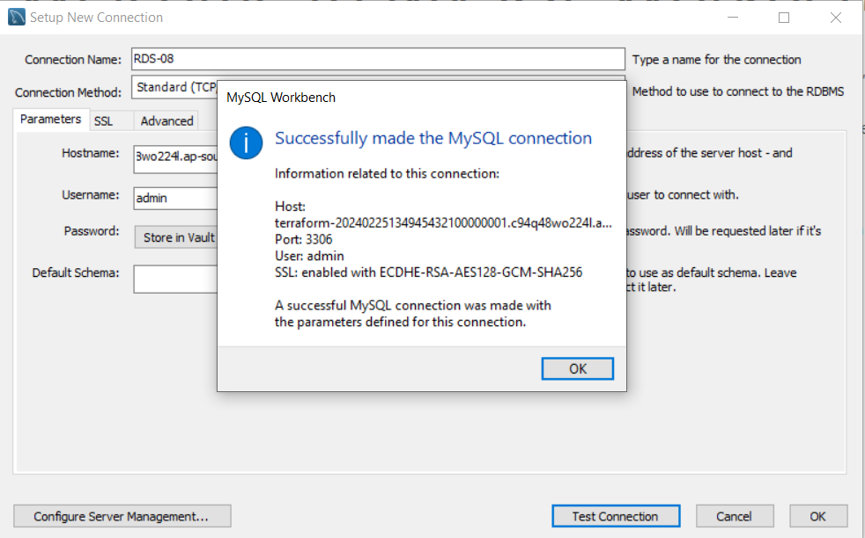

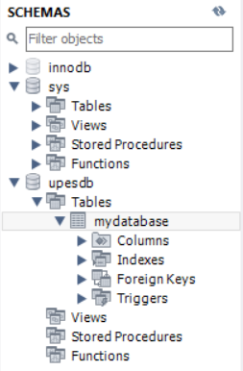

Step 9: Now Destroying the rds created.

